Uncertainty estimation of conventional neutron-spectrum
unfolding codes with Monte-Carlo based method

Katsumi AOKI¹, Tadahiro KIN¹, Md Kawchar Ahmed PATWARY¹, Kosuke YOSHINAMI¹,
Masaya YAMAGUCHI¹, Masatoshi ITOH², Yukinobu WATANABE¹
¹Department of Advanced Energy Engineering Science, Kyushu University
²Cyclotron and Radioisotope Center, Tohoku University
e-mail: aoki.katsumi.473@s.kyushu-u.ac.jp

Unfolding process has been applied to neutron spectra derivation of many measurement methods. Previously, many types of unfolding techniques have been developed. Many codes of them, however, cannot calculate uncertainty propagation, and thus uncertainty characteristics comparison of some codes has not been investigated. To solve this problem, we have developed an uncertainty estimation method based on Monte-Carlo technique. Moreover, we have investigated characteristics of uncertainty propagation of two unfolding codes, GRAVEL and MAXED. For demonstration, we measured a double-differential thick-target neutron yield (DDTTNY) of the C(d,n) reaction induced by 20-MeV deuterons with the multiple-foil activation method at Cyclotron and Radioisotope Center, Tohoku University. The measured data were analyzed by GRAVEL and MAXED, and their uncertainty propagation was estimated by using the present method. As a result, we found that the uncertainty of DDTTNY has neutron energy dependence, and the dependency trend is different between GRAVEL and MAXED codes.

- Introduction
Accelerator-based neutron source has recently been applied to various field such as boron neutron capture therapy (BNCT) [1], radioisotopes (RIs) production [2, 3], nuclear transmutation [4], and nuclear fusion engineering [5]. Among them, we have been focusing on RI production using neutrons generated by the (d,n) reaction with a neutron convertor made of thick carbon or beryllium. The generated neutrons irradiate a raw material, and RI is produced. In the RI production system, ⁶⁴Cu [6], ⁹²Y [7], and ^{99m}Tc [8] productions were proposed previously.
In research and development of the RI production method, simulation plays an important role for estimation of production amount and its purity, the design of irradiation system, and shielding calculation. For accurate simulation, double-differential thick-target neutron yields (DDTTNYs) should be preknowledge. In practical RI production applications, the DDTTNYs of the (d,n) reactions from 10- to 50-MeV deuterons are necessary. However, systematically sufficient experimental data are not available.
For improvement of this situation, we have measured the DDTTNYs by the multiple-foil activation method. In the method, DDTTNY $ϕ_{E_{j}}$ is derived by unfolding process that is to solve an inverse problem expressed by the following equation:

$\left(\begin{matrix}N_{x} \\ N_{y} \\ \begin{matrix}⋮ \\ N_{i} \\ \begin{matrix}⋮ \\ N_{n}\end{matrix}\end{matrix}\end{matrix}\right)= \left(\begin{matrix}R_{x,E_{1}} & R_{x,E_{2}} & ⋯ & R_{x,E_{j}} & ⋯ & R_{x,E_{m}} \\ R_{y,E_{1}} & R_{y,E_{2}} & ⋯ & R_{y,E_{j}} & ⋯ & R_{y,E_{m}} \\ ⋮ & ⋮ & ⋱ & ⋮ & & ⋮ \\ R_{i,E_{1}} & R_{i,E_{2}} & ⋯ & R_{i,E_{j}} & ⋯ & R_{i,E_{m}} \\ ⋮ & ⋮ & & ⋮ & ⋱ & ⋮ \\ R_{n,E_{1}} & R_{n,E_{2}} & ⋯ & R_{n,E_{j}} & ⋯ & R_{n,E_{m}}\end{matrix}\right)\left(\begin{matrix}ϕ_{E_{1}} \\ ϕ_{E_{2}} \\ \begin{matrix}⋮ \\ ϕ_{E_{j}} \\ \begin{matrix}⋮ \\ ϕ_{E_{m}}\end{matrix}\end{matrix}\end{matrix}\right)$ , | (1)

where $N_{i}$ and $R_{i,E_{j}}$ represent the number of produced atoms via the reaction $i$ and the production rate of reaction $i$ with a neutron energy group $j$, respectively. In general, the number of activation reactions of interest ($n$) is less than the number of neutron energy groups ($m$). In the past, many unfolding algorithms have been developed, for example, an iterative approximation method, a maximum entropy method, an iterative Bayesian method, and an artificial neural network (ANN) method. However, we do not know that characteristics of the propagated uncertainty of unfolding codes.
To overcome the situation, we have developed a random sampling algorithm of estimating the uncertainty propagation in DDTTNYs derived by the unfolding process. In our study, we pay attention to GRAVEL [9] and MAXED [10] codes which are conventionally used for neutron spectrum unfolding. These codes are based on the iterative approximation method and the maximum entropy method, respectively. The GRAVEL code cannot analytically calculate the propagation of experimental uncertainties. Using the random sampling algorithm, we have compared the uncertainty propagation in the unfolding process with GRAVEL and MAXED.

- Monte-Carlo based uncertainty estimation method
We proposed an algorithm for estimating uncertainty based on Monte-Carlo technique for unfolding process. The flow chart of the algorithm is shown in Fig. 1.
Firstly, measured number of produced atoms $N_{i}$ of interested reaction is randomly changed by Gaussian distribution having statistical uncertainty. The changed number of atoms $N_{i}^{'}$ is calculated by following equation:

$N_{i}^{'}= N_{i}+ε_{i}N_{i}d$ , | (2)

where $d$ and $ε_{i}$ represent a random number generated by standard normal distribution and experimental relative uncertainty of $i$-th reaction. Secondly, we derived a neutron spectrum by an unfolding code with $N_{i}^{'}$. The process, which changed number of atoms is generated and neutron spectrum is derived, is conducted iteratively. Then, neutron spectra give two-dimensional distribution like Fig. 2. In each neutron energy group, we calculate standard deviation of DDTTNYs. The standard deviations mean propagated uncertainty of DDTTNY. The algorithm is considered only statistical uncertainty of the measured number of atoms $N_{i}$.
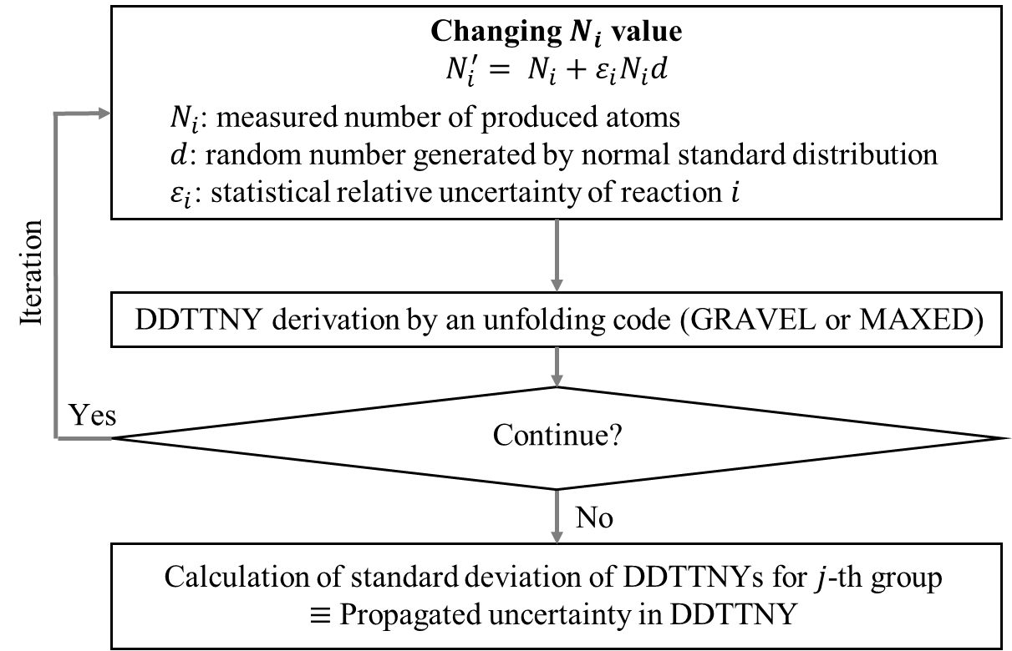
Fig. 1 Flow chart of a random sampling algorithm for estimating propagated uncertainty
in unfolding process of deriving DDTTNYs.
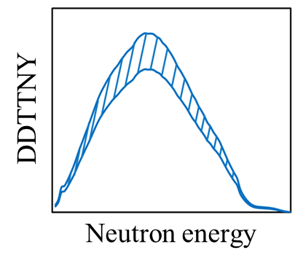
Fig. 2 Example of two-dimension distribution of distorted DDTTNYs
for bins of neutron energy and DDTTNY.

- Experiment
For demonstration of our developing algorithm, we conducted DDTTNY measurement by multiple-foil activation method at Cyclotron and Radioisotope Center (CYRIC), Tohoku University. Deuterons were accelerated to 20 MeV by an AVF930 cyclotron and bombarded on a thick carbon target (23 mm $×$ 23 mm $×$ 2 mm^{t}). The accelerator-based neutrons were generated via the C(d,n) reaction. The generated neutrons irradiated multiple foils (50 mm $×$ 50 mm). The foils were made of Al (0.025 mm^{t}), Fe (0.02 mm^{t}), Co (0.1 mm^{t}), Ni (0.1 mm^{t}), Zn (0.2 mm^{t}), Zr (0.1 mm^{t}), and Mo (0.05 mm^{t}). The foils placed at 1,215 mm downstream to the carbon target at 0 degree to direction of deuteron beam. Average deuteron beam current was about 2.0 $μ$A during 19-hours irradiation. Figure 3 shows the schematic view of irradiation setup. After the irradiation, we measured gamma-ray emitted from activated multiple foils with HPGe detector.
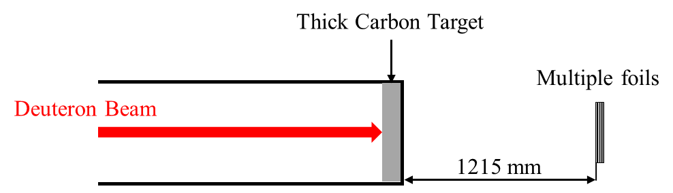
Fig. 3 Schematic view of the irradiation setup. The accelerator-based neutrons generated
via the C(d,n) reaction irradiated multiple foils (Al, Fe, Co, Ni, Zn, Zr and Mo).

- Results and Discussion
Firstly, the number of produced atoms by activation reactions of interest was derived from counting rate of photo peaks in measured gamma-ray spectra. The derived number of atoms and their statistical uncertainties are shown in Table 1.
Secondly, to calculate the production rate functions, the cross sections [cm²] stored in JENDL-4.0 [11] were multiplied by solid angle of each foil [sr], total charge of deuteron beam [$μ$C] and surface density of atoms [cm⁻²]. The production rate functions are shown in Fig. 4.
Both GRAVEL and MAXED require initial guess spectrum in unfolding process to derive resultant spectrum. The initial guess spectrum was calculated by deuteron-induced reaction analysis code system (DEURACS) [12] which is a theoretical calculation code for deuteron induced reactions.

Table 1 Interested activation reaction, the number of produced atoms,
and statistical uncertainty measured in the gamma-ray experiment.
Reaction | Half life | Number of produced atoms
²⁷Al(n,a)²⁴Na | 15.0 h | 5.30$×$10⁷ $±$ 2.30$×$10⁵
⁵⁶Fe(n,p)⁵⁶Mn | 2.58 h | 1.28$×$10⁷ $±$ 1.37$×$10⁵
⁵⁹Co(n,a)⁵⁶Mn | 2.58 h | 1.90$×$10⁷ $±$ 1.12$×$10⁵
⁵⁹Co(n,p)⁵⁹Fe | 44.5 d | 2.68$×$10⁸ $±$ 1.38$×$10⁶
⁵⁸Ni(n,2n)⁵⁷Ni | 35.6 h | 1.24$×$10⁷ $±$ 1.03$×$10⁵
⁶⁴Zn(n,p)⁶⁴Cu | 12.7 h | 6.91$×$10⁸ $±$ 9.56$×$10⁶
⁶⁷Zn(n,p)⁶⁷Cu | 61.8 h | 7.59$×$10⁶ $±$ 7.76$×$10⁴
⁹⁶Zr(n,2n)⁹⁵Zr | 64.0 d | 7.00$×$10⁷ $±$ 7.49$×$10⁵
⁹⁶Mo(n,p)⁹⁶Nb | 23.4 h | 1.63$×$10⁶ $±$ 2.47$×$10⁴
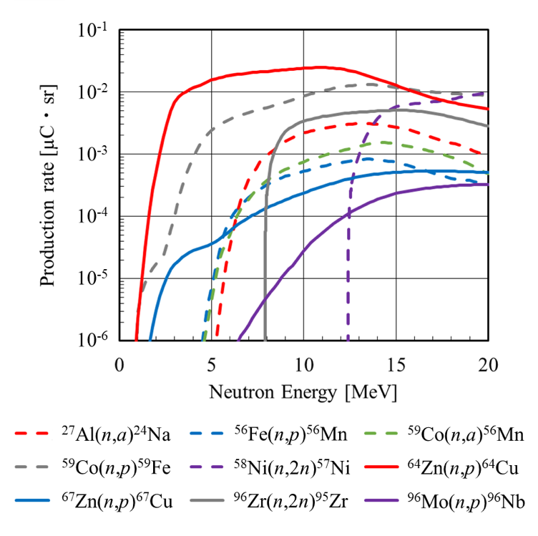
Fig. 4 Production rate plotted as a function of neutron energy for each activation reaction. The production rate functions were calculated from cross section extracted from JENDL-4.0, solid angle of each foil, total charge of deuteron beam, and surface density of atoms.

The propagated uncertainties of each code were calculated by the developed algorithm. The standard deviation $ε_{i}$ of eq. (2) was set to the original experimental statistical relative uncertainty. Then, 1,000 spectra were calculated by random sampling as shown in Fig.1. Figure 5 shows two-dimensional histograms of the 1,000 DDTTNYs for case of DDTTNY derivation in (a) GRAVEL and (b) MAXED codes. For each code, we found that uncertainties have neutron energy dependence and the trend is completely different even they used same original uncertainties. In resultant DDTTNY of GRAVEL has large propagated uncertainty around 1-7 MeV of neutron energy range. In contrast to that, resultant DDTTNY of MAXED has large propagated uncertainty around higher energy range around 7-16 MeV. Moreover, the resultant spectrum is almost same as the initial guess spectrum in lower energy range (1-5 MeV). That is because our interested reactions were not occurred in the energy range, and unfolded DDTTNYs never adjusted in the range in the unfolding process by MAXED which is well-known to have strong initial guess spectrum dependency.

- Conclusion
We have developed an algorithm for estimating propagated uncertainty in unfolding process of deriving DDTTNY. The algorithm is based on Monte-Carlo method and can apply to many unfolding codes. In this work, we applied it to GRAVEL and MAXED used in unfolding process and investigated difference of neutron energy dependence of propagated uncertainty between two unfolding codes. For demonstration, we conducted accelerator-based neutron spectrum measurement by multiple-foil activation method. We derived the DDTTNY and its uncertainty by using our developing algorithm. From the results, we found neutron energy dependency and trend of the dependencies is completely different.
In the future, we will apply the algorithm to other unfolding codes based on the iterative Bayesian and artificial neutral network methods.

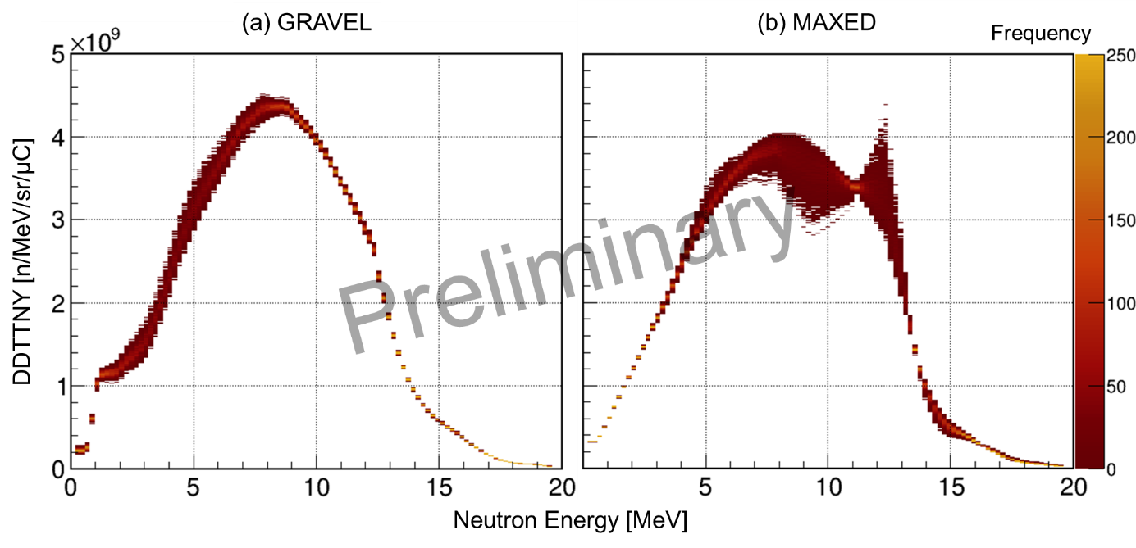
Fig. 5 Preliminary results about two-dimensional histogram of 1000 DDTTNYs derived
in (a) GRAVEL and (b) MAXED.

Reference
[1] | M. Yoshioka, Review of Accelerator-based Boron Neutron Capture Therapy Machines, in Proceedings of IPAC 2016, 3171, 2016 (2016).
[2] | Y. Nagai, et al., J. Phys. Soc. Jpn. 82, 064201 (2013).
[3] | T. Kin, et al., J. Phys. Soc. Jpn. 24, 011031 (2019).
[4] | Implications of Partitioning and Transmutation in Radioactive Waste Management, Number 435 in Technical Reports Series, IAEA, Vienna (2004).
[5] | A. Moeslang, et al., Fusion Engineering and Design 81, 863 (2006).
[6] | T. Kin, et al., J. Nucl. Sci. Technol. 54, 1123 (2017).
[7] | T. Kin, et al., M. Itoh, EPJ Web Conf. 146, 08009 (2017).
[8] | Y. Nagai, et al., J. Phys. Soc. Jpn. 78, 033201 (2009).
[9] | M. Matzke, Report PTB-N-19 (1994).
[10] | M. Reginatto, et al., Nucl. Instrum. Methods, A476, 242 -246 (2002).
[11] | K. Shibata, et al., J. Nucl. Sci. and Technol. 48, 1 (2011).
[12] | S. Nakayama, et al., Phys. Rev. C 94, 014618 (2016).

