日本語表題
J-PARCにおける0.4 GeV – 3.0 GeV陽子を用いたZ=26-30元素に対する核種生成断面積測定

著者名
松田洋樹
竹下隼人
岩元大樹
明午伸一郎

Measurement of nuclide production cross sections for Z = 26-30 elements irradiated with 0.4 - 3.0 GeV proton in J-PARC

Hiroki Matsuda¹, Hayato Takeshita², Hiroki Iwamoto¹, and Shin-ichiro Meigo¹
¹ J-PARC Center, Japan Atomic Energy Agency, 2-4 Tokai-mura, Ibaraki 319-1195, Japan
² Department of Advanced Energy Engineering Science, Kyushu University, Kasuga, Fukuoka 816-8580, Japan
email: matsuda.hiroki@jaea.go.jp

For the design of Accelerator-Driven nuclear transmutation System (ADS), accurate cross section data are required to estimate the number of radioactive nuclides for treating radioactive wastes in the ADS plant. Although much effort has been devoted to obtaining the nuclide production cross section irradiated by protons in the energy region utilized for the ADS at several facilities so far, data with systematic uncertainties of ~10% exist. Furthermore, no experimental data still exist around for protons in a few GeV region. In order to validate the calculation code and the evaluated data utilized for the ADS, we started the experiment to obtain the cross section at 3-GeV synchrotron in J-PARC. In this study, we obtained nuclide production cross section for targets with Z numbers from 26 to 30 (i.e., ^{nat}Fe, ^{nat}Ni, and ^{nat}Zn), which are important regions for the estimation of the radioactivity of the ADS structural materials. Furthermore, we investigated the incident energy dependency on the cross section from several hundred MeV to 3 GeV using the present and the previous experimental data, comparing with different intra-nuclear cascade and evaporation models of INCL4.6/GEM, INCL++/ABLA07, and Bertini/GEM, and evaluated nuclear data of JENDL-HE2007.

- Introduction
Accelerator-Driven nuclear transmutation System (ADS) transmutes minor actinides (MA) by supplying neutrons continuously. Neutrons are supplied by a spallation reaction of lead-bismuth eutectic (LBE) irradiated by 1.5 GeV energy protons, which is also utilized as coolant. For the estimation of the radioactive nuclides to treat wastes and evaluate the chemical effect of spallation products in the LBE, accurate cross section data are required. Although much effort has been devoted to conducting nuclide production cross section measurements at several facilities since the 1950s, the uncertainties of data, being typically about 10%, are not good enough to validate the calculation model. Furthermore, data around in a few GeV region, which are candidates for projectile energies of the ADS, have larger uncertainty than other regions. Thus, the experiment was performed in J-PARC. In this study, we obtained nuclide production cross section for targets with Z numbers from 26 to 30 (i.e., ^{nat}Fe, ^{nat}Ni, and ^{nat}Zn), which are important regions for the estimation of the radioactivity of the ADS structural materials. They were irradiated by proton beams having different energies of 0.4, 1.3, 2.2, and 3.0 GeV. A comparison between the experimental data and the calculations were demonstrated. In this paper, the details of the experiment and analysis procedure for Zn target are described. The results of Fe and Ti have been already reported [1,2].

- Experiment
  - Setup
The basic experiment setup was the same as Ref. [3]. The experiment was carried out at the beam transport line from the RCS [4] to the Materials and Life Science Experimental Facility (MLF), which is called as 3NBT. Thin square foils of Fe, Ni, and Zn, 0.1 mm thick and 25mm long, were sandwiched with thin aluminum foil with 0.1mm thick to evaluate the number of recoil nuclides. Four sets of this sample were placed at the head of each linear stage guide. They were placed in the vacuum chamber that was installed in the beam dump line. A linear stage guide was controlled remotely to insert and extract samples.

  - Irradiation
Each sample set was irradiated by 0.4, 1.3, 2.2, and 3.0 GeV protons, respectively. The 0.4 GeV beam was transported from the LINAC without acceleration. The other energies were obtained by changing the extraction timing of the kicker magnet at RCS. The beam width and position were measured with the multi-wire profile monitor (MWPM) installed in the beamline. The number of protons in the beam was monitored by the current transformer (CT). Beam profile measurement using an imaging plate (IP) was performed after irradiation to improve the accuracy of the beam position on the samples. Repetition of shots was set to 0.4 Hz to avoid melting of samples. In total, 40 shots, i.e., $2.32×{10}^{14}$ protons, were irradiated for each target. After irradiation, the linear stage guides were removed from the chamber. The cooling time, which is the time interval between the end of the irradiation to the beginning of the measurement, was approximately six to nine hours.

  - Analysis
Decay gamma-rays from irradiated samples were measured by the high pure germanium detector (HPGe, Mirion Technologies GC2018). The list of activation products analyzed in this paper was summarized in table 1.
The samples were mounted on the acrylic spacer apart from the head of HPGe by about 5 cm or 25 cm to keep detector-to-sample geometry rigidly. The production cross section of specified nuclei $σ$ was written as
$σ=\frac{C}{t_{l}ϵI_{γ}μ}×\frac{t_{r}}{1- exp⁡(-λt_{r})}×\frac{\exp\left(λt_{c}\right)}{N_{p}n}$ … (1)
where $C$ is the number of count of a peak, $t_{l}$ is so-called live-time which includes deadtime correction during measurement, $ϵ$ is the efficiency at the peak energy, $I_{γ}$ is the absolute gamma-ray intensity, $μ$ is the self-absorption correction, $t_{r}$ is so-called real-time, $λ$ is the decay constant of the nuclide, $N_{p}$ is the number of protons irradiated, and $n$ is the number density of the sample.
Table 1 The list of nuclides analyzed
Nuclide | Half-life
⁷Be | 53.22 d
²²Na | 2.6018 y
⁴⁸Cr | 21.56 h
⁵⁴Mn | 312.20 d
⁵²Fe | 8.275 h
⁵⁵Co | 17.53 h
⁵⁸Co | 70.86 d
⁵⁷Ni | 35.60 h
⁶¹Cu | 3.389 h
⁶⁴Cu | 12.701 h
⁶²Zn | 9.193 h
⁶⁵Zn | 243.93 d
Here the correction during irradiation was not applied since the irradiation time was considerably shorter than the half-life of products. The recoil particles could be trapped by the forward and backward aluminum foils. They were observed in the actual aluminum foil. However, the activity of them was evaluated as a negligible amount. Thus, this correction was not applied in this experiment. The effects of secondary particles affecting the backward samples were also estimated by the simulation. Since very thin samples were employed in this experiment, the number of secondary particles was lower than the irradiated protons in the order of three or four digits. Hence, this effect was not considered in this analysis. The number density of the sample $n$ is derived by
$n=\frac{m}{MS}N_{A}$ … (2)
where $m$ is the sample mass that is measured by the electric scale, $S$ is the surface area of the sample, $M$ is the atomic weight of the sample, and $N_{A}$ is Avogadro constant. The self-absorption correction $μ$ is calculated by
$μ=\frac{1-\exp\left(μ_{\text{att}}ρt\right)}{μ_{\text{att}}ρt}$ … (3)
where $μ_{\text{att}}$ is the attenuation coefficient, $ρ$ is the sample density, and $t$ is the thickness of the sample. Detector efficiency of the HPGe was evaluated by using ²⁴¹Am, ¹⁵²Eu, ⁶⁰Co, and ¹³⁷Cs standard gamma-ray sources, which were put at the same position as the samples. Sum-peak corrections for multi gamma-ray sources were applied [5].
The number of protons and beam profile (width and position) were measured precisely by the CT and the MWPM, respectively. Beam profile measurement using an IP (FUJI-FILM BAS-SR2040) was also performed to improve the accuracy of the beam profile. The irradiated samples were placed onto the IP to expose. After exposure, the IP was scanned by the image processor (GE healthcare Typhoon FLA 7000). Scanned images were fit by a two-dimensional Gaussian to evaluate the width and position of the beam. Here the Gaussian shape was guaranteed by the measurement of the MWPM. Finally, the fractions of the proton beam on the sample foils were derived by integrating the function over the sample area. As a result, the fractions ranged from 0.98 to 1.00. This fraction was used for the final correction.
The sample surface area was measured by a typical image scanner (EPSON GT-S650).

  - Uncertainty estimation
Table 2 Table of uncertainties
Description | Estimated uncertainty %
Statistics of gamma-ray count | <0.1 – 10
Detector efficiency | 1.0
Sample weight | <0.1
Sample surface area | 1.4
Time | <0.1
Self-absorption | 0.1
The number of protons | 1
Imaging plate | <0.1
Branching ratio | <0.1 – 30
In total | 2.0 – 31.7
The list of uncertainties concerned is shown in table 2. The uncertainty of the detector efficiency was the standard deviation of differences between measured points and calculated ones. Imaging plate uncertainty, namely the uncertainty of irradiated proton fraction, was evaluated as the standard deviation of proton fraction of all samples at the same energy. The reading uncertainty of scanning of 1mm scale with 800 dots/inch, i.e., 314.96 dots/mm, was 1 dot. In addition, an ambiguity for an edge detection could be estimated as 2 dots. Thus, the uncertainty of the sample surface was evaluated as 1.4% by a square root of the sum of the square of 3/314.96.

- Results and observations
The PHITS code [6] was employed to calculate the production cross sections with two intranuclear cascade models (Bertini and INCL4.6 [7]) and generalized evaporation model (GEM). The calculation by using the INCL++ code [8] with INCL++v6.0.1 and ABLA07 [9] models was also performed. The number of histories was sufficiently large, so that calculation uncertainties were negligible. In Fig. 1, the measured, the calculated, and the evaluated cross sections of JENDL-HE/2007 [10] for each production cross sections of zinc were shown. The other experimental data were taken from EXFOR [11].

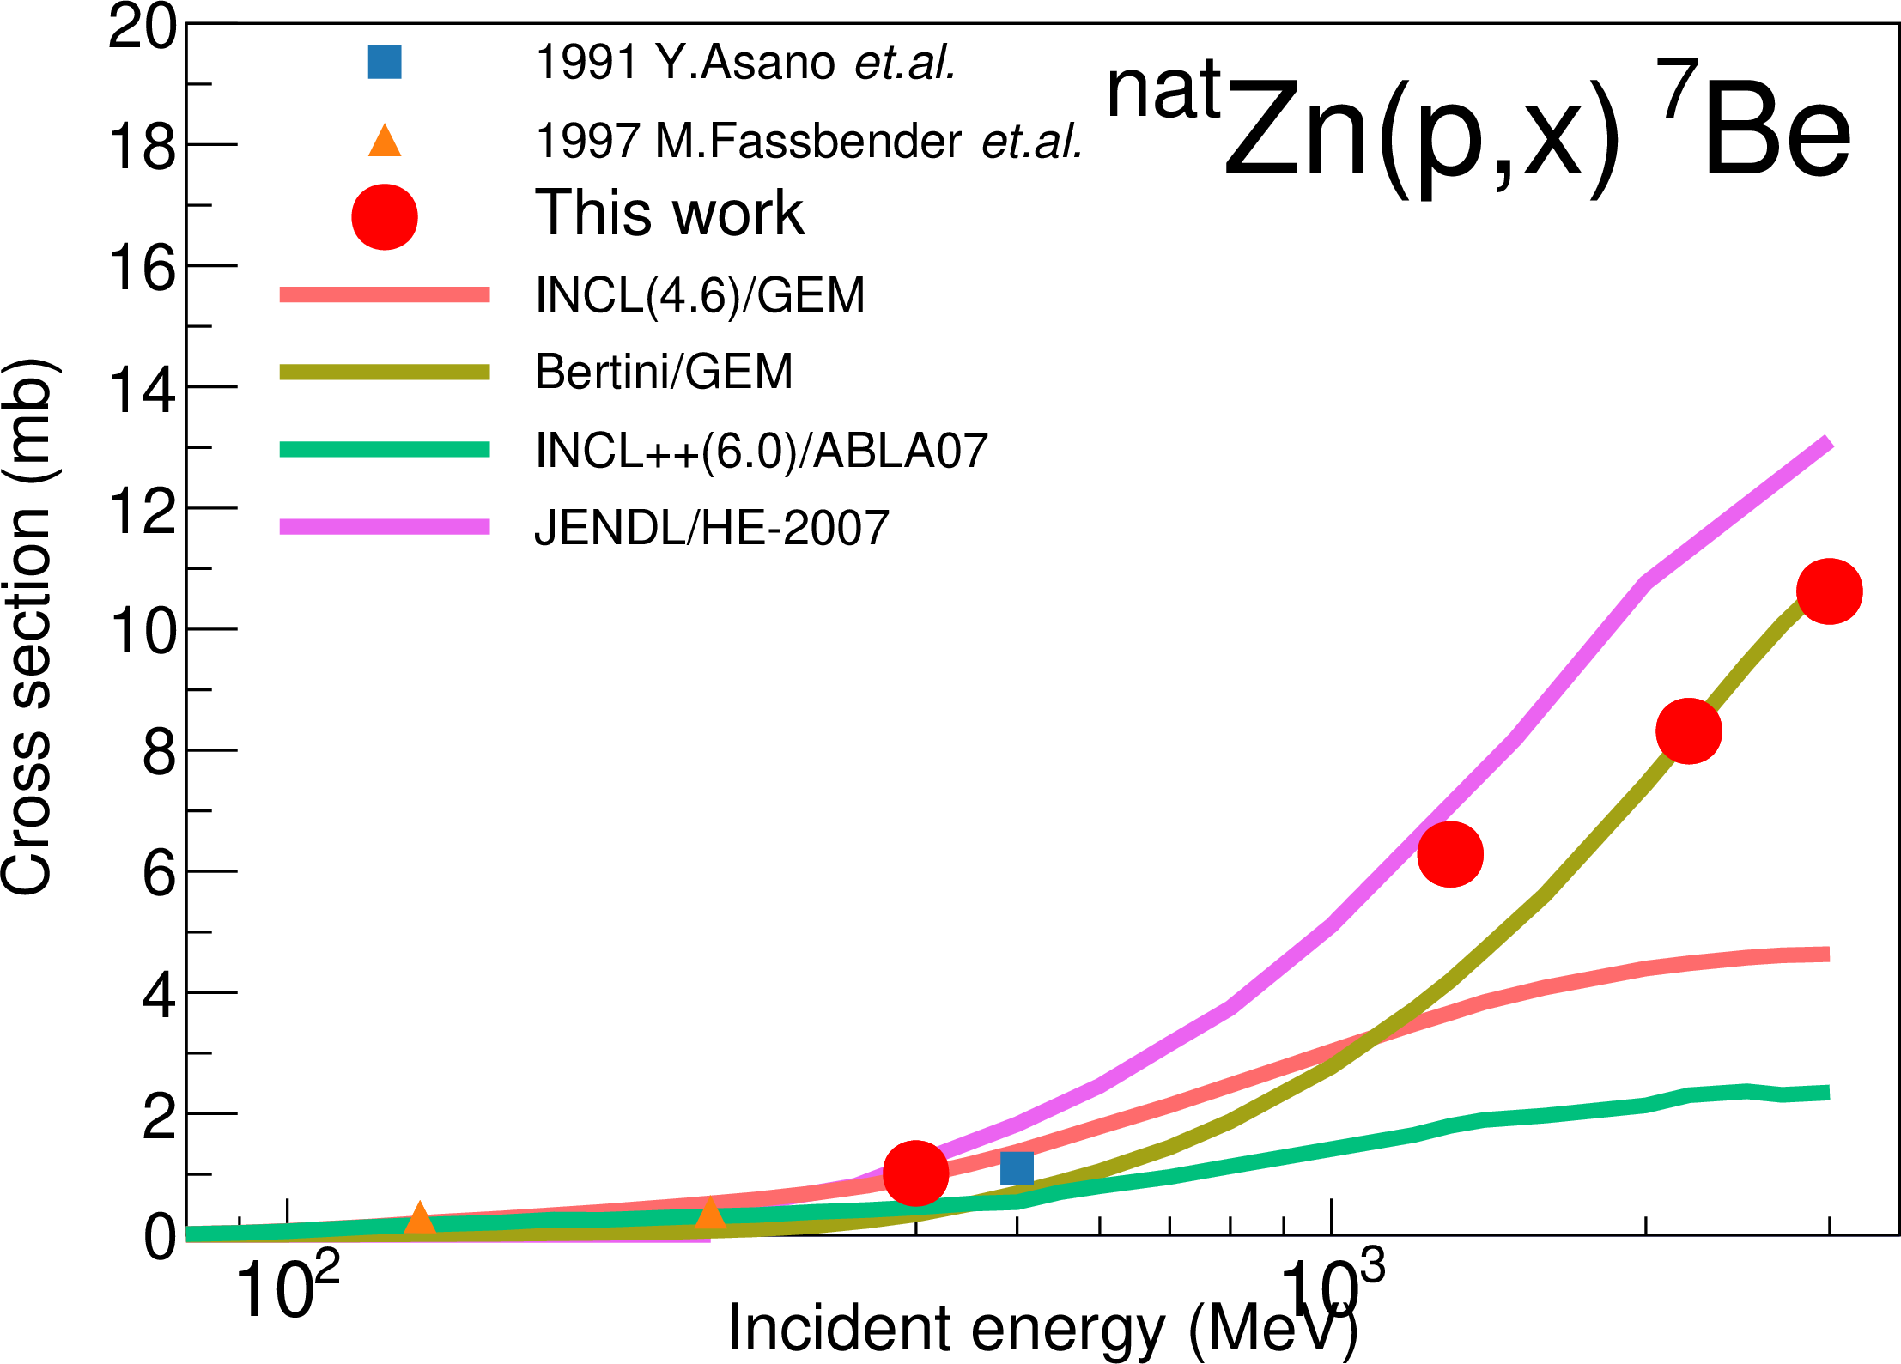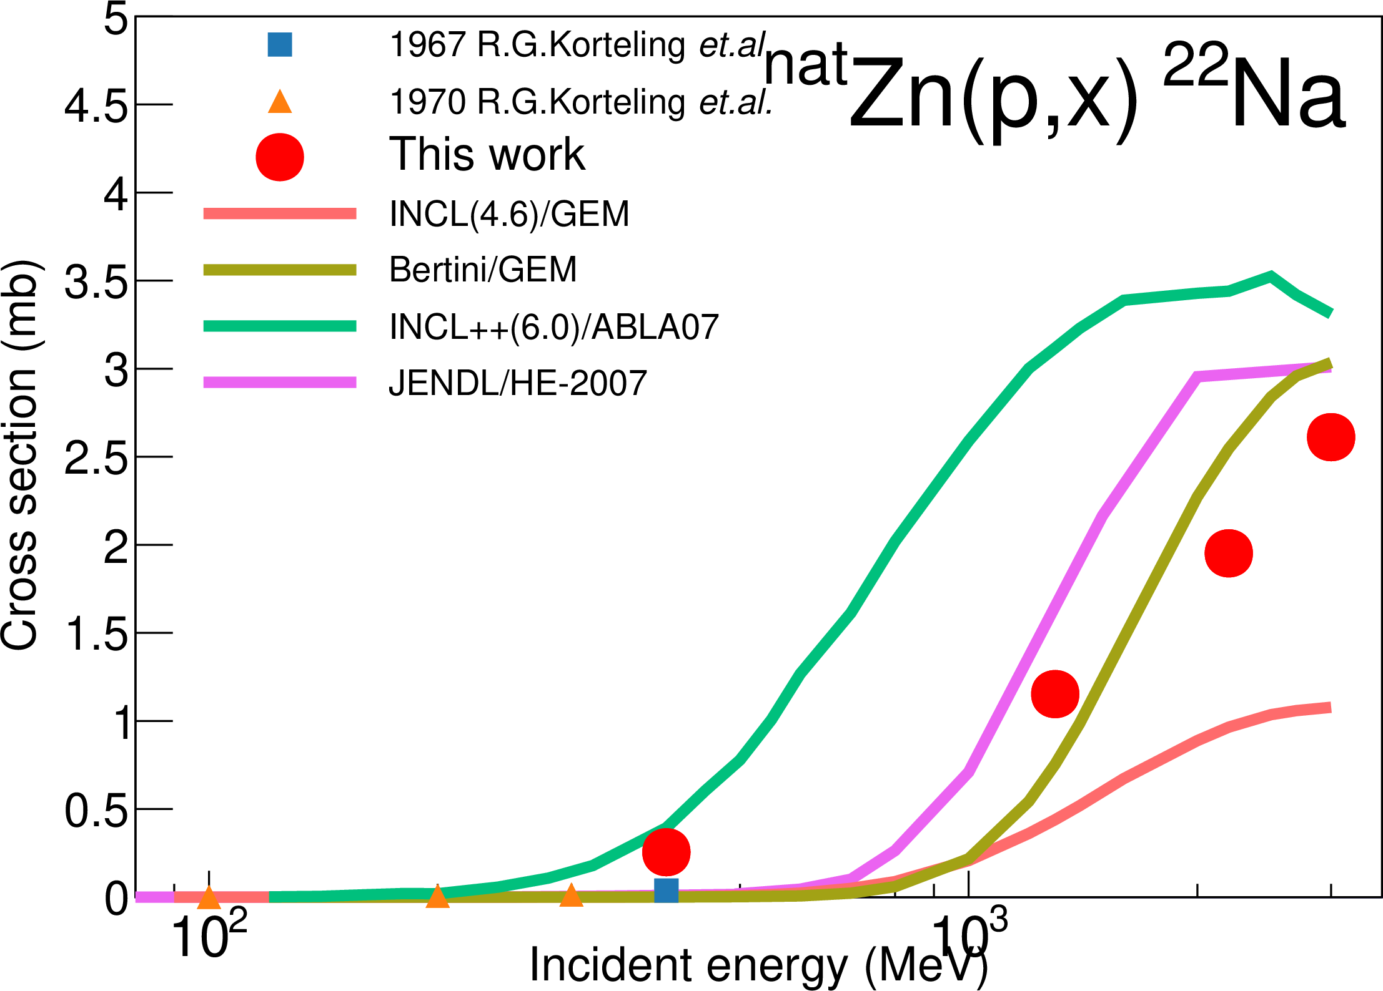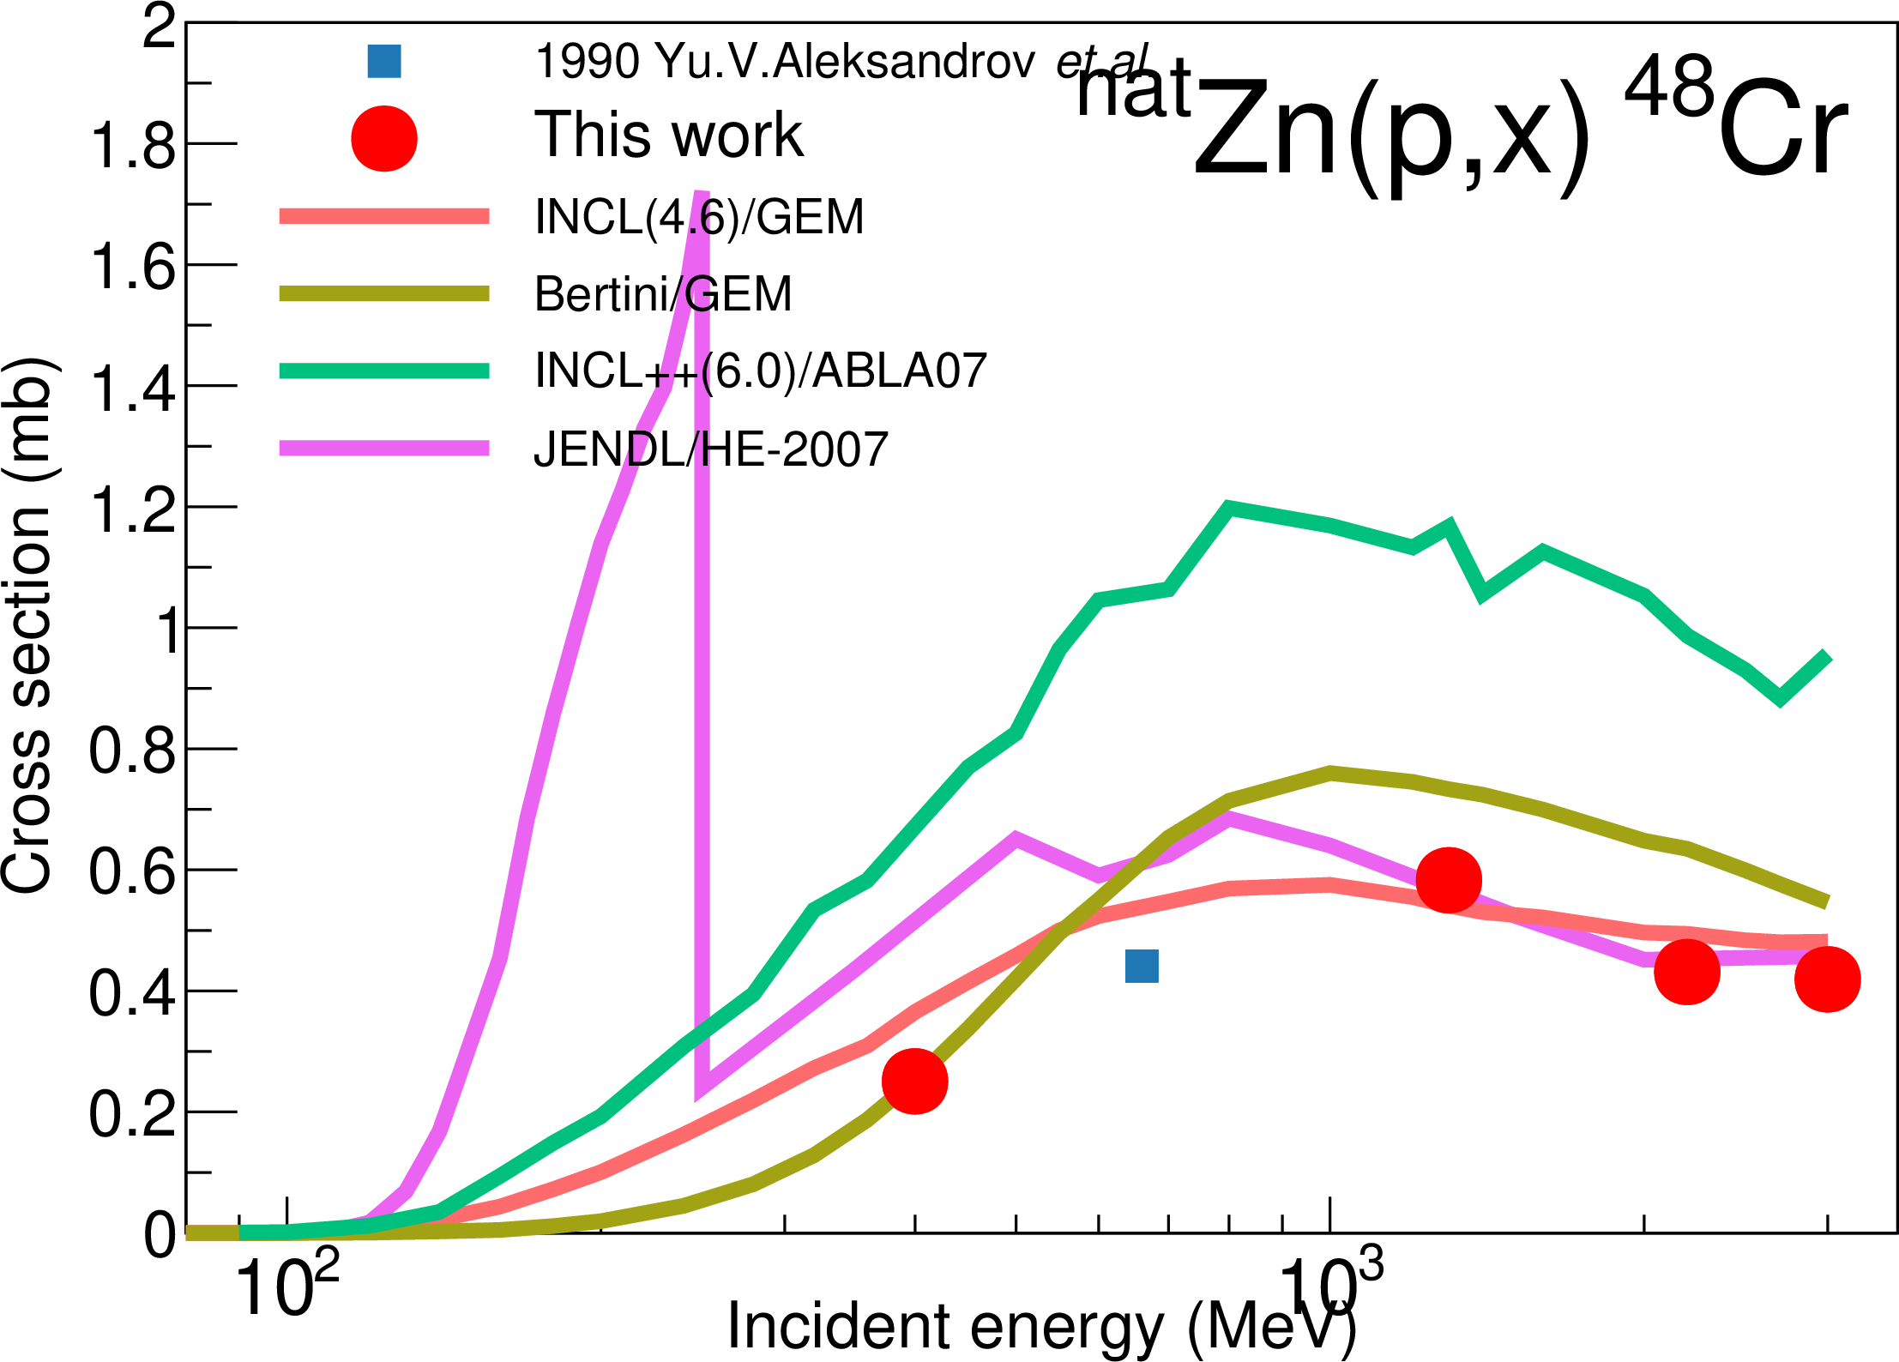
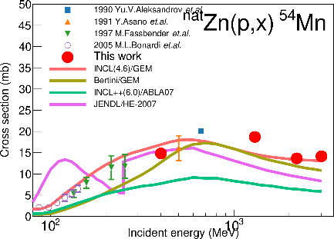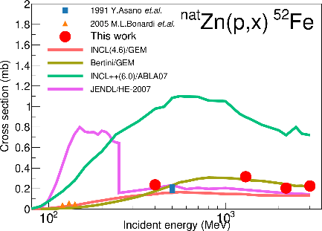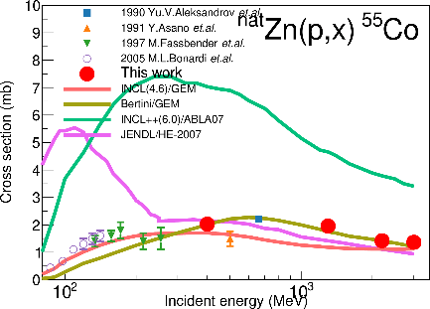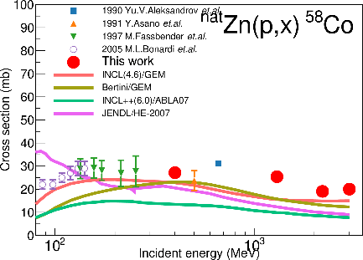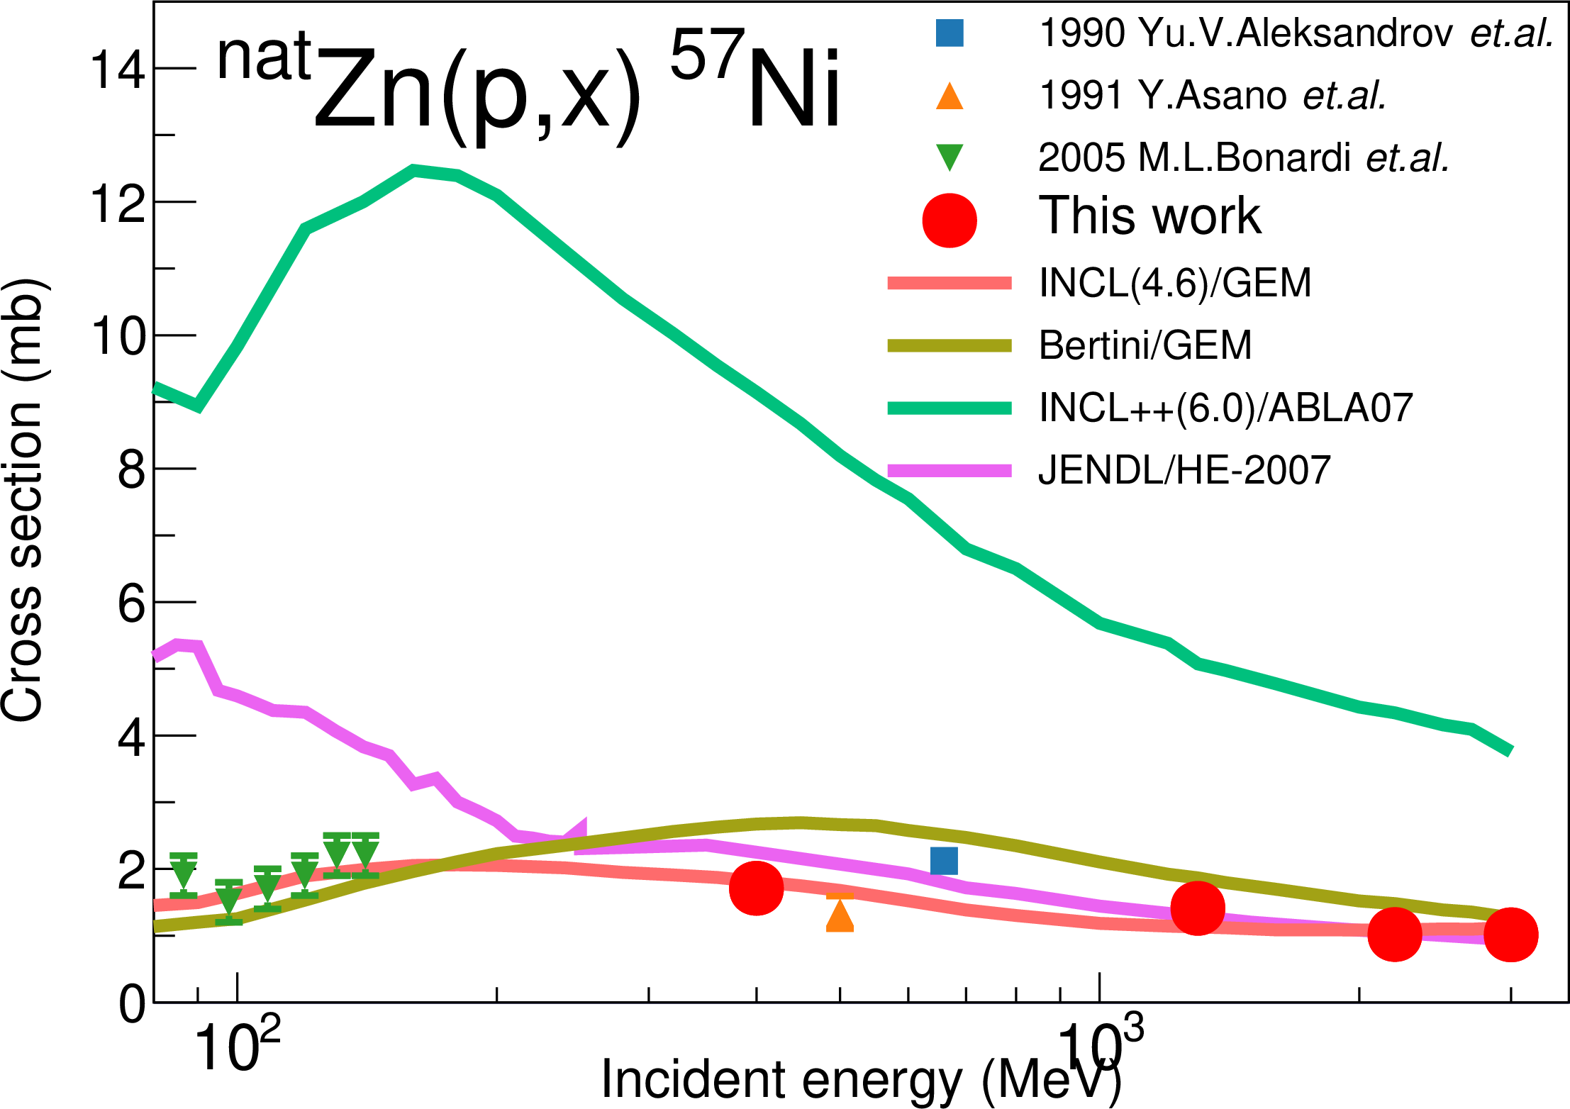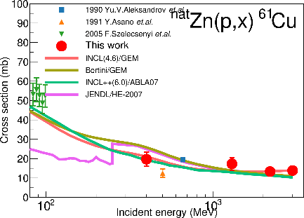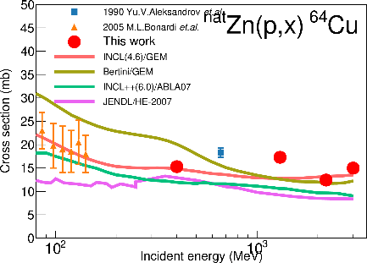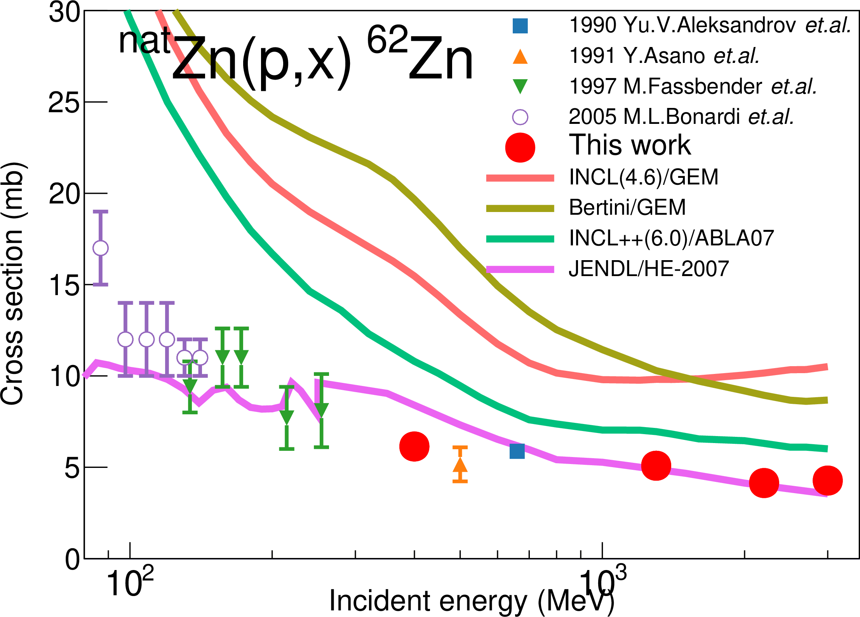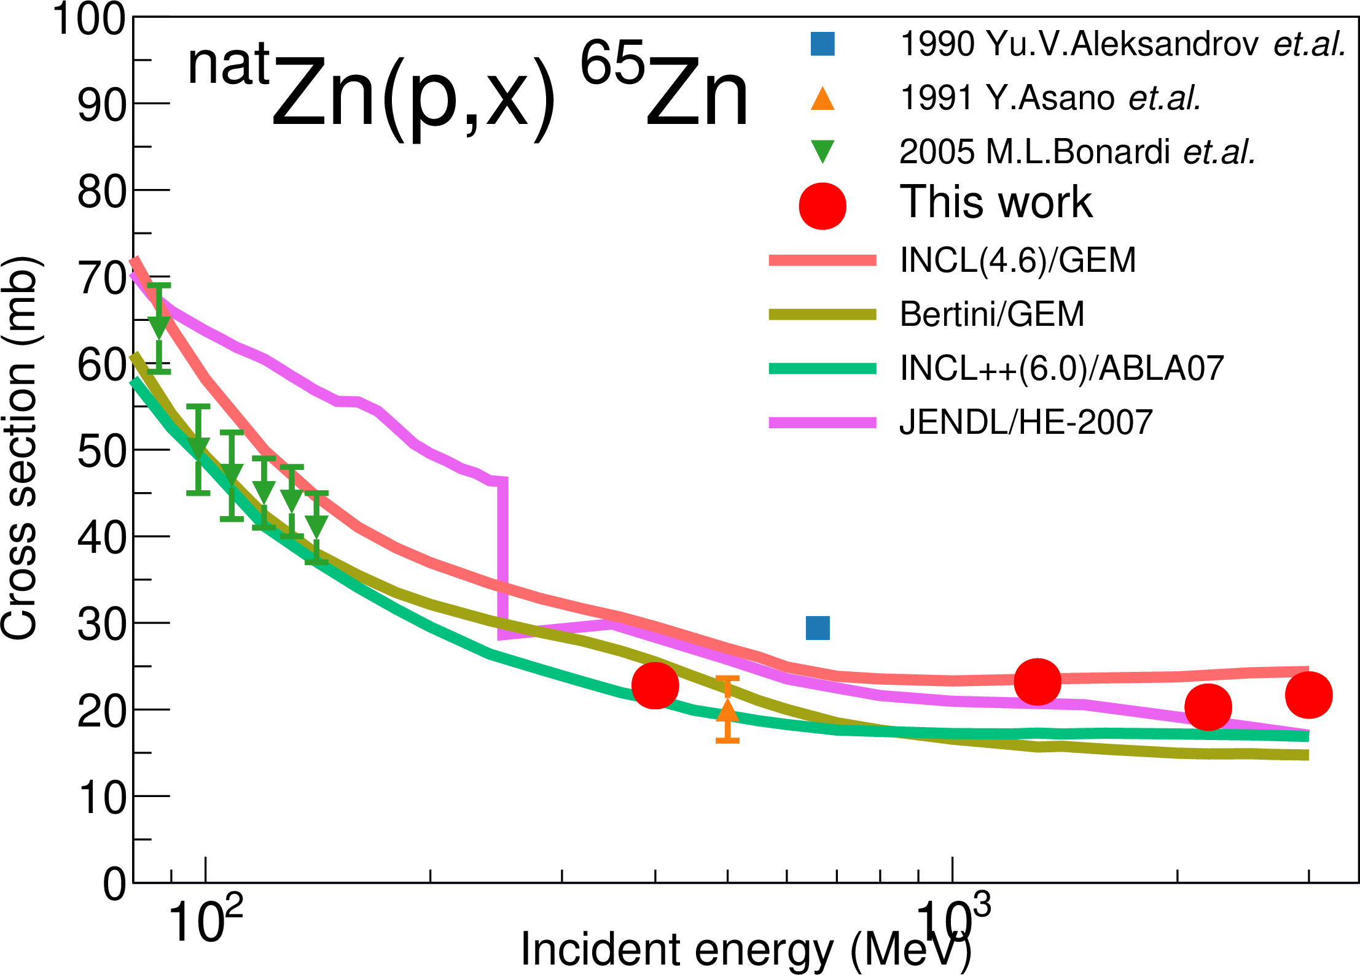
Figure 1 Production cross sections of ⁷Be, ²²Na, ⁴⁸Cr, ⁵⁴Mn, ⁵²Fe, ⁵⁵Co, ⁵⁸Co, ⁵⁷Ni, ⁶¹Cu, ⁶⁴Cu, ⁶²Zn, and ⁶⁵Zn from ^{nat}Zn. This works (red filled circle), other experiments (colored other symbols) taken from EXFOR, calculations (colored solid lines), and the evaluated data (magenta solid line) are plotted.

For all production cross sections shown in this paper, PHITS calculations agreed with the experimental data. In the light nuclide productions such as ⁷Be and ²²Na, Bertini model gave better agreement than INCL4.6. INCL4.6 calculations agreed with heavier nuclide productions, i.e., less than 10 nucleons emission reactions. In contrast, INCL++ code overestimated or underestimated for almost all productions. This tendency was also observed in the cross section with Fe and Ni targets [1,2]. JENDL-HE/2007 agreed with the experimental data for all cross sections though it showed strange behavior below 150 – 250 MeV, in which the evaluation method was changed from the GNASH code to a microscopic simulation code (either JAM or JQMD).

- Summary
The production cross sections from Zn with 0.4, 1.3, 2.2, and 3.0 GeV protons were measured at J-PARC. In total, more than 30 cross sections were obtained with higher accuracy than other experimental data in the past thanks to quite stable J-PARC beam and monitoring systems. The present results were compared with the calculations and the evaluated nuclear data. The present experimental data suggested that further improvement of models is mandatory in the GeV energy region. The evaluated data was in good agreement with the experimental data.

Acknowledgment
The authors are grateful to Mrs. Nishikawa and Hirano, and the members of Nippon Advanced Technology (NAT) for technical assistance with the experiments and to Drs. Saha, Hotchi, and Harada for tuning of the RCS.

References
- H. Matsuda, et al., Atomic Energy Society of Japan, 2019 Spring Meeting, Mar. 2019 (in Japanese)
- H. Takeshita, et al., Atomic Energy Society of Japan, 2019 Fall Meeting, Sep. 2019 (in Japanese)
- H. Matsuda, S. Meigo, H. Iwamoto, J. Nucl. Sci. Technol. 3131, 1 (2018)
- S. Meigo, F. Noda, S. Ishikura, et al., Nucl. Instruments Methods Phys. Res. Sect. A Accel. Spectrometers, Detect. Assoc. Equip. 562, 569 (2006)
- E. Tomarchio, S. Rizzo, Radiat. Phys. Chem. 80, 318 (2011)
- T. Sato, Y. Iwamoto, S. Hashimoto, et al., J. Nucl. Sci. Technol. 3131, 1 (2018)
- A. Boudard, J. Cugnon, J.C. David, et al., Phys. Rev. C 87, 014606 (2013)
- D. Mancusi, A. Boudard, J. Cugnon, et al., Phys. Rev. C 90, 054602 (2014)
- A. Kelic, M.V. Ricciardi, K.H. Schmidt (2009), arxiv:0906.4193
- Y. Watanabe, K. Kosako, S. Kunieda, et al., J. Korean Phys. Soc. 59, 1040 (2011)
- V. Zerkin, B. Pritychenko, Nucl. Instruments Methods Phys. Res. Sect. A Accel. Spectrometers, Detect. Assoc. Equip. 888, 31 (2018)

