Production of ¹⁶⁹Yb by the proton-induced reaction on ¹⁶⁹Tm

Moemi Saito¹, Masayuki Aikawa^{1,2*}, Tomohiro Murata¹, Yukiko Komori³, Hiromitsu Haba³,
Sándor Takács⁴, Ferenc Ditrói⁴ and Zoltán Szűcs⁴
¹ Graduate School of Biomedical Science and Engineering, Hokkaido University, Sapporo 060-8638, Japan
² Faculty of Science, Hokkaido University, Sapporo 060-0810, Japan
³ Nishina Center for Accelerator-Based Science, RIKEN, Wako 351-0198, Japan
⁴ Institute for Nuclear Research (ATOMKI), 4026 Debrecen, Hungary
*e-mail: aikawa@sci.hokudai.ac.jp

Activation cross sections of the ¹⁶⁹Tm(p,n)¹⁶⁹Yb reaction were measured using the MGC-20E cyclotron at Institute for Nuclear Research (ATOMKI), Hungary. The stacked-foil activation technique and the high-resolution gamma-ray spectrometry were adopted to derive the cross sections. The preliminary cross sections were compared with experimental data studied earlier and with theoretical model calculation.

1. Introduction
The radionuclide ¹⁶⁹Yb (T_{1/2} = 32.018 d) decays with emissions of Auger electrons and X-rays. These properties of ¹⁶⁹Yb are appropriate for brachytherapy [1]. For such practical use, the best reaction for its production should be selected among all possible reactions. One of them is the neutron capture reaction on ¹⁶⁸Yb, of which the isotopic ratio is only 0.123%. Another route is a reaction using charged particles, such as proton, deuteron and alpha particles. We have systematically investigated the production reactions of ¹⁶⁹Yb with a focus on the charged-particle induced reactions. The experiments on deuteron- [2] and alpha-induced reactions on ¹⁶⁹Tm, and alpha-induced reactions on ^{nat}Er [3] have already been performed. Therefore, we carried out an experiment of the proton-induced reaction on ¹⁶⁹Tm. In this paper, we report the preliminary result of this experiment.

2. Experimental
The experiment was performed using the MGC-20E cyclotron at Institute for Nuclear Research (ATOMKI), Hungary. The stacked-foil activation technique and the high-resolution gamma-ray spectrometry were adopted to derive cross sections.
The target consisted of metallic foils of ¹⁶⁹Tm (99.0% purity) and ^{nat}Ti (99.6% purity). The sizes and weights of the foils were measured for determining the average thicknesses of the Tm and Ti foils. The thicknesses were found to be 21.0 and 9.1 mg/cm², respectively. The foils were cut into small pieces of 6×6 mm² and stacked into a target holder, which was also served as a Faraday cup. The target was irradiated for 30 min with an 18 MeV proton beam. Energy degradation in the target was calculated using the SRIM code [4]. The average beam intensity was 210 nA, which was measured by the Faraday cup. Gamma rays emitted from each irradiated foil were measured by a HPGe detector without chemical separation. Nuclear data required to derive cross sections were obtained from NuDat 2.7 [5] and QCalc [6] and summarized in Table 1.

Table 1. Reaction and decay data for ¹⁶⁹Yb production
Nuclide | Half-life | Decay mode (%) | E_{γ} (keV) | I_{γ} (%) | Contributing reaction | Q-value (MeV)
¹⁶⁹Yb | 32.018 d | EC (100) | 177.21 | 22.28(11) | ¹⁶⁹Tm(p,n) | -1.7

3. Results
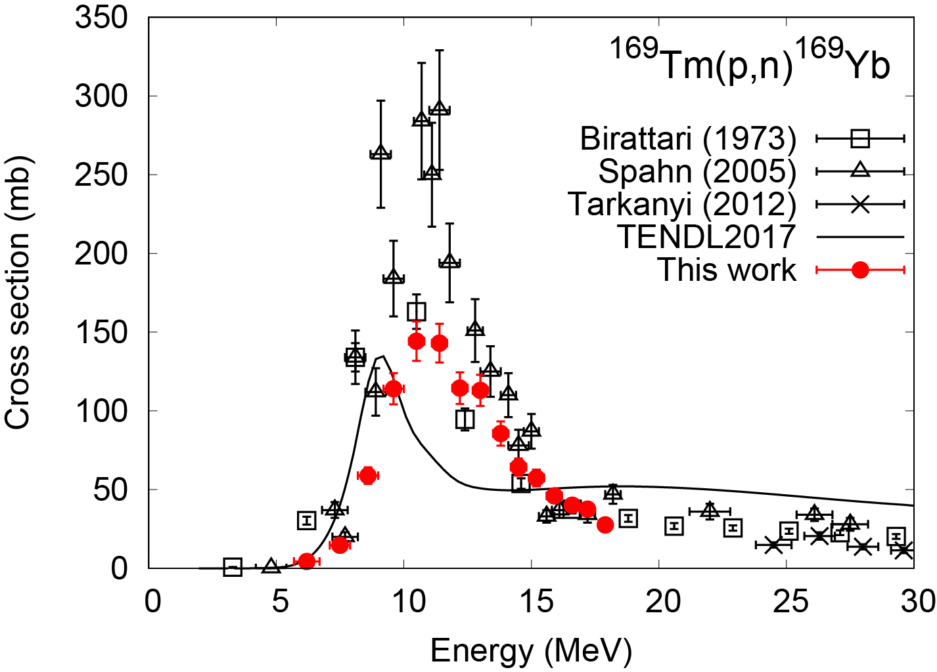
Fig. 1. Excitation function of the ¹⁶⁹Tm(p,n)¹⁶⁹Yb reaction with the previous data [7–9] and the TENDL-2017 data [10].
The 177.21-keV gamma rays (I_{γ} = 22.28%) emitted with the ¹⁶⁹Yb decay (T_{1/2} = 32.018 d) were measured after a cooling time of about 4 days. The cross sections of the ¹⁶⁹Tm(p,n)¹⁶⁹Yb reaction were derived from the measurements and the nuclear data in Table 1. The preliminary result is shown in Fig. 1 in comparison with the previous experimental data [7–9] and the TENDL-2017 data [10]. The peak amplitude of the data of Birattari et al. (1973) [7] is almost consistent with our result. However, the data of Spahn et al. (2005) [8] shows two times larger amplitude than ours. The peak of the TENDL-2017 data show the similar amplitude with ours, however smaller width and lower energy position than ours.

4. Summary
We measured activation cross sections of the ¹⁶⁹Tm(p,n)¹⁶⁹Yb reaction up to 18 MeV. The experiment was performed using the cyclotron at ATOMKI. The well-established methods, the stacked-foil activation method and the gamma-ray spectrometry, were adopted. The preliminary result of the cross sections was compared with previous experimental data and theoretical model calculation. The further analysis is being performed.

Acknowledgements
This work was carried out at Institute for Nuclear Research (ATOMKI), Hungary. This work was partly supported by “Optimization of accelerator production routes of the new theranostic radioisotopes Sc-47 and Cu-67 (FY2019-2020)”, under the Japan - Hungary Research Cooperative Program, JSPS and HAS and JSPS KAKENHI Grant Number 17K07004.

References
[1] Leonard KL, DiPetrillo TA, Munro JJ, et al. A novel ytterbium-169 brachytherapy source and delivery system for use in conjunction with minimally invasive wedge resection of early-stage lung cancer. Brachytherapy. 2011;10:163–169.
[2] Saito M, Aikawa M, Komori Y, et al. Production cross sections of ¹⁶⁹Yb and Tm isotopes in deuteron-induced reactions on ¹⁶⁹Tm. Appl. Radiat. Isot. [Internet]. 2017;125:23–26. Available from: http://dx.doi.org/10.1016/j.apradiso.2017.04.010.
[3] Saito M, Aikawa M, Sakaguchi M, et al. Production cross sections of ytterbium and thulium radioisotopes in alpha-induced nuclear reactions on natural erbium. Appl. Radiat. Isot. [Internet]. 2019;154:108874. Available from: https://doi.org/10.1016/j.apradiso.2019.108874.
[4] Ziegler JF, Biersack JP, Ziegler MD. SRIM: the Stopping and Range of Ions in Matter [Internet]. 2008. Available from: http://www.srim.org.
[5] National Nuclear Data Center. Nuclear structure and decay data on-line library, Nudat 2.7 [Internet]. 2017. Available from: http://www.nndc.bnl.gov/nudat2/.
[6] Pritychenko B, Sonzogni A. Q-value Calculator (QCalc) [Internet]. 2003. Available from: http://www.nndc.bnl.gov/qcalc/.
[7] Birattari C, Gadioli E, Gadioli Erba E, et al. PRE-EQUILIBRIUM PROCESSES IN (p,n) REACTIONS. Nucl. Phys. A. 1973;201:579–592.
[8] Spahn I, Takács S, Shubin YN, et al. Cross-section measurement of the ¹⁶⁹Tm(p,n) reaction for the production of the therapeutic radionuclide ¹⁶⁹Yb and comparison with its reactor-based generation. Appl. Radiat. Isot. 2005;63:235–239.
[9] Tárkányi F, Hermanne A, Takács S, et al. Activation cross-sections of proton induced nuclear reactions on thulium in the 20-45MeV energy range. Appl. Radiat. Isot. 2012;70:309–314.
[10] Koning AJ, Rochman D, Sublet J-C, et al. TENDL: Complete Nuclear Data Library for Innovative Nuclear Science and Technology. Nucl. Data Sheets. 2019;155:1–55.

