Improvement of fuel ion ratio diagnostics performance
using anisotropic neutron emission spectrum in NBI heating deuterium-tritium plasma

Tomoki Urakawa and Hideaki Matsuura
Department of Applied Quantum Physics and Nuclear Engineering, Kyushu University,
744 Motooka Nishi-ku Fukuoka 819-0395, Japan
e-mail : urakawa-0804@nucl.kyushu-u.ac.jp

For the stable operation of the deuterium-tritium (DT) fusion reactor, it is important to know the triton to deuteron fuel-ion density ratio (n_{T}/n_{D}) during the operation. A method to obtain the n_{T}/n_{D} density ratio from the emission ratio of 14 MeV neutron by DT reaction and 2.45 MeV neutron by DD reaction has been studied. This method has a serious problem that the detection of 2.45 MeV neutron by DD reaction is interfered by slowing-down component of 14 MeV neutrons by DT reaction. As a solution to this problem, a technic increasing the fraction of the DD to DT reaction rate and utilizing modification of the DT and DD neutron emission spectra by NBI-heating has been studied. Owing to this technic, the measurement has found to be possible even when n_{T}/n_{D} = 1.0. However, the detectable plasma condition is still limited, and further improvement is required. In this study, we consider neutron measurement using the anisotropic neutron spectrum for further improvement of the diagnostics performance. We indicate the effectiveness of the proposed method by discussing the range of detectable plasma condition.

- Introduction
Diagnostic to measure the fuel ion ratio in deuterium-tritium (DT) fusion plasma is important to stably operate and control a fusion reactor. Requirement for fuel ion ratio diagnostics are over the parameter range of 0.01 < n_{T}/n_{D} < 10, spatial resolution of a/10, where ‘a’ is the minor radius of the plasma [1]. In the ITER, plasma operation over the parameter range of 0.1 < n_{T}/n_{D}< 3.0 is assumed. Recently, various methods to know the fuel-ion density ratio such as gamma-ray measurement [2], charge exchange recombination spectrometry [3], collective Thomson scattering [4] and neutron measurement [5], have been proposed. The devices for the above measurement will be installed in ITER for the practical examination of the diagnostic [6]. In fuel ion ratio diagnostic using neutron measurement, each intensity of neutron spectrum peaks by the deuterium-deuterium (DD) and deuterium-tritium (DT) reactions are measured. Fuel ion ratio is given by
$$\frac{n_{T}}{n_{D}}= \frac{R_{DT}{<σv>}_{DD}}{2R_{DD}{<σv>}_{DT}} , (1)$$
where R_{DD} and R_{DT} are each DD and DT reaction rates, n_{T} and n_{D} are the number density of triton and deuteron, and <σv>_{DD} and <σv>_{DT} are the reaction rate coefficients for DD and DT reaction. As a serious problem of this diagnostics, the detection of DD neutron (Signal) is interfered by slowing-down component of DT neutrons (Noise). Due to the above problem, high measurement accuracy for both neutron production rates is required to distinguish between the Signal and Noise. And, it is also important to understand the spectrum of the Noise using neutron transport calculation [7]. As a result, in the case of thermal plasma, it has been reported that the detectable parameter range is n_{T}/n_{D} < 0.6 and Ti > 6 keV [1].
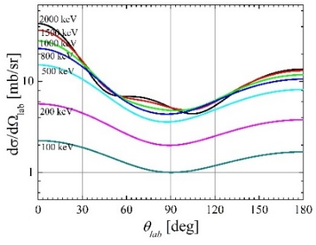
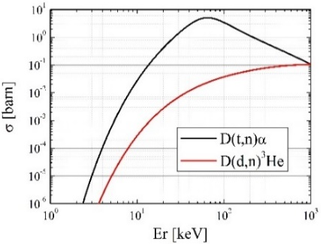
In order to improve the measurement performance, technic using the rise in the fraction of the DD to DT reaction rate and modification of the neutron emission spectra by NBI-heating has been studied [8]. First, the degree of enhancement for the DD reaction rate coefficient is much larger than that for DT due to the cross section of Fig. 1 [9]. Thus, DT noise could be relatively reduced compared with DD signals. In beam-injected plasma, the shape of neutron emission spectra significantly changed (non-Maxwellian component is formed in ion velocity distribution function). By considering the modification of the neutron emission spectrum, i.e., shifting the measurement energy region to the higher energy side, we can reduce the Noise to Signal ratio. In Ref [8], possibility of measurement at n_{T}/n_{D} = 1.0 was shown by using the method. But, evaluation of the detectable parameter range is still insufficient by only examining Ref [8]. And, further improvement is necessary for measurement of ITER class plasma.
Fig. 2 Differential Cross section
Fig. 1 Cross section
In NBI heating plasma, emission spectrum of the particle which produced fusion reaction has anisotropy in addition to modified from Gaussian [10]. Due to anisotropic emission, the population of energetic particle is higher in the NBI incident direction. In the case of D(d,n)³He reaction, anisotropy appears greatly due to differential cross section. Fig. 2 shows differential cross section of D(d,n)³He reaction [11]. The modification from Gaussian to the high energy side is even greater since forward emission is dominant from Fig. 2. Thus, performance of the fuel ion diagnostic using modified neutron emission spectrum measurement may be more improved due to considered anisotropic.
In this study, we evaluate the improvement of fuel ion diagnostic performance using anisotropic neutron emission spectra based on S/N value. And, we indicate the effectiveness of the anisotropic neutron emission spectra measurement comparing with the isotropic neutron emission spectra.
- Calculation model
2-1 Double differential neutron emission spectrum
In Fig. 3, the double differential emission spectrum for neutron as a function of neutron energy and emission angle relative to the beam-injection direction in the laboratory system is shown. This neutron emission spectrum was assumed to be obtained from the ITER like plasma sustained by NBI heating. In Fig. 3, plasma parameter is assumed as follow; n_{e} = 5.0×10¹⁹ m⁻³, T_{e} = 10 keV, P_{NBI} = 33 MW, E_{NBI} = 1.0 MeV, τ_{E} = 3.0 s and n_{T}/n_{D} = 1.0. Here n_{e} is electron density, T_{e} is electron temperature, P_{NBI} is beam power, E_{NBI} is beam energy, τ_{E} is energy confinement time. In this study, we assumed tangential deuteron beam to the toroidal magnetic field. Beam-particle slowing down is calculated using analytic model described in Ref. [12]. The velocity distribution functions of the triton and deuteron (bulk component) are assumed to be Maxwellian. We calculate this neutron emission spectrum using the method described in Ref. [10]. The double differential neutron emission energy spectrum is written as
$$\frac{d^{2}N_{n}}{dEdΩ_{lab}}\left(E,θ_{lab}\right)= \frac{1}{1+δ_{DD(T)}}\iiint{f_{D}(\left|{\vec{v}}_{D}\right|)f_{D(T)}(\left|{\vec{v}}_{D(T)}\right|)\frac{dσ}{dΩ}}$$
$$×δ\left(E-E_{n}\right)δ\left(Ω_{lab}-Ω_{n}\right)v_{r}d{\vec{v}}_{D}d{\vec{v}}_{D\left(T\right)}dΩ , (2)$$
where E_{n} is the neutron energy in the laboratory system [13];
$$E_{n}= \frac{1}{2}m_{n}V_{c}^{2}+\frac{m_{{}_{}^{3}{He}\left(α\right)}}{m_{n}+m_{{}_{}^{3}{He}\left(α\right)}}(Q_{DD(DT)}+E_{r})$$
$$+V_{c}\cos{θ_{c}\sqrt{\frac{2m_{{}_{}^{3}{He}\left(α\right)}}{m_{n}+m_{{}_{}^{3}{He}\left(α\right)}}\left(Q_{DD\left(DT\right)}+E_{r}\right)} , (3)}$$
where m_{n(}³_{He,α)} is the neutron (3-helium, α-particle) mass, V_{c} is the center-of-mass velocity of the colliding particles, θ_{c} is the angle between the center-of-mass velocity and the neutron velocity in the center-of-mass frame, Q_{DD(DT)} is each reactions Q-value, and E_{r} represents the relative energy given by
$$E_{r}= \frac{1}{2}\frac{m_{D}m_{D(T)}}{m_{D}{+m}_{D(T)}}\left|{\vec{v}}_{D}{-\vec{v}}_{D(T)}\right| . (4)$$
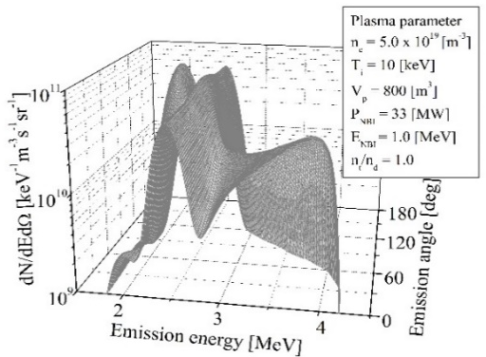
The θ_{lab} represents the angle between the direction of emitted neutron and that of beam injection in the laboratory system, and Ω_{n} is a unit vector in the direction of emission of neutron in the laboratory system, which is determined using the classical kinematics as a function of ${\vec{v}}_{D}$, ${\vec{v}}_{D\left(T\right)}$$v_{r}$, and $θ_{c}$. In Section 3.1, we discuss using only the neutron emission spectrum shown in Fig.1 as a neutron source. On the other hands in Section 3.2, we calculate the neutron source using analysis models in Ref. [9] and Ref. [12] for each plasma parameter and do the following discussion.
Fig. 3 Double differential emission
spectrum of DD neutron
2-2 Neutron transport calculation
2-2-1 Blanket with detector model
Fig. 4 shows the computational schema of the blanket systems with collimator (detector). In Fig. 4, the collimator direction, φ, was set to be the angle made with respect to the extended line in the NBI incident direction when viewed from the blanket (upper view). The blanket model was employed the torus form which has a 6.2 m major radius and a 2.0 m minor radius. And, blanket material component and each layer thickness is shown in Table 1 [13]. The collimator is a pillar 10 cm in inner diameter and 20 cm in outer diameter. And the length of collimator is 114 cm. These conditions were set based on Ref. [8] and Ref. [14].

2-2-2 Signal and Noise calculation
Table 1 Blanket component
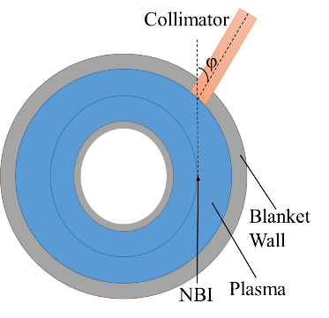
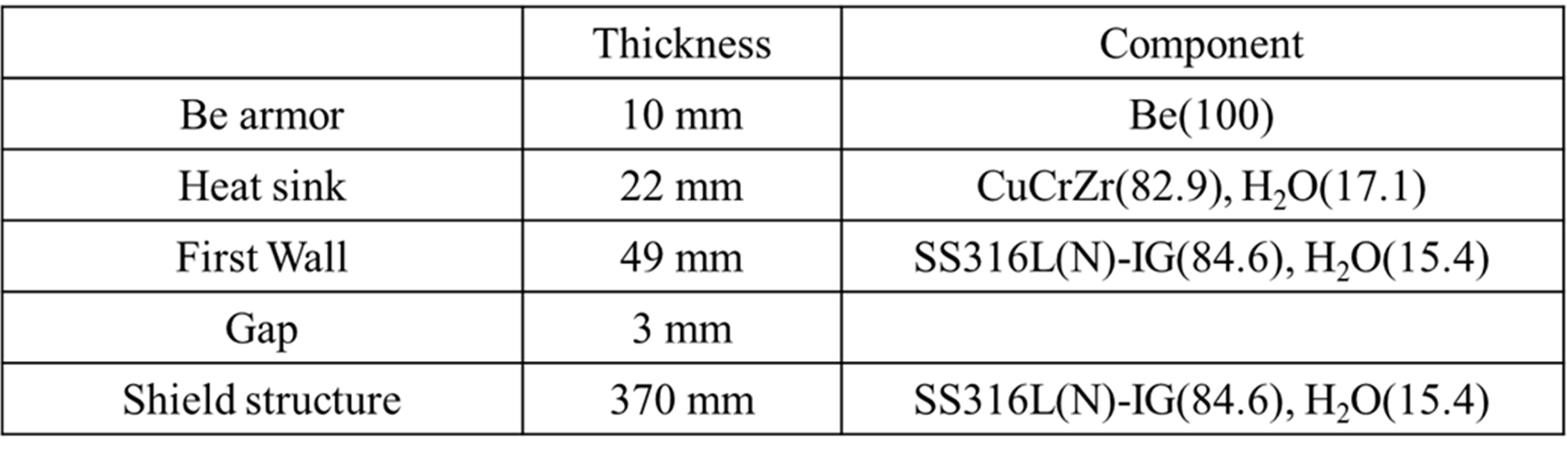
Incident DD neutron spectrum in the detector (Signal) and slowing-down component of DT neutrons (Noise) was calculated using the Monte Carlo transport code MVP [15] with the JENDL-4.0 [16] nuclear data library. In this study, we adopted point detector estimator in calculating Signal and Noise. The validity of this calculation method is shown in Ref. [1]. Throughout the simulation, the measurement energy range of neutron detection set to Ec±240 keV (Ref. [5]), where Ec is center energy in the measurement energy range.
- Result and discussion
Fig. 4 Blanket and collimator
3-1 Incident neutron spectrum on detector surface
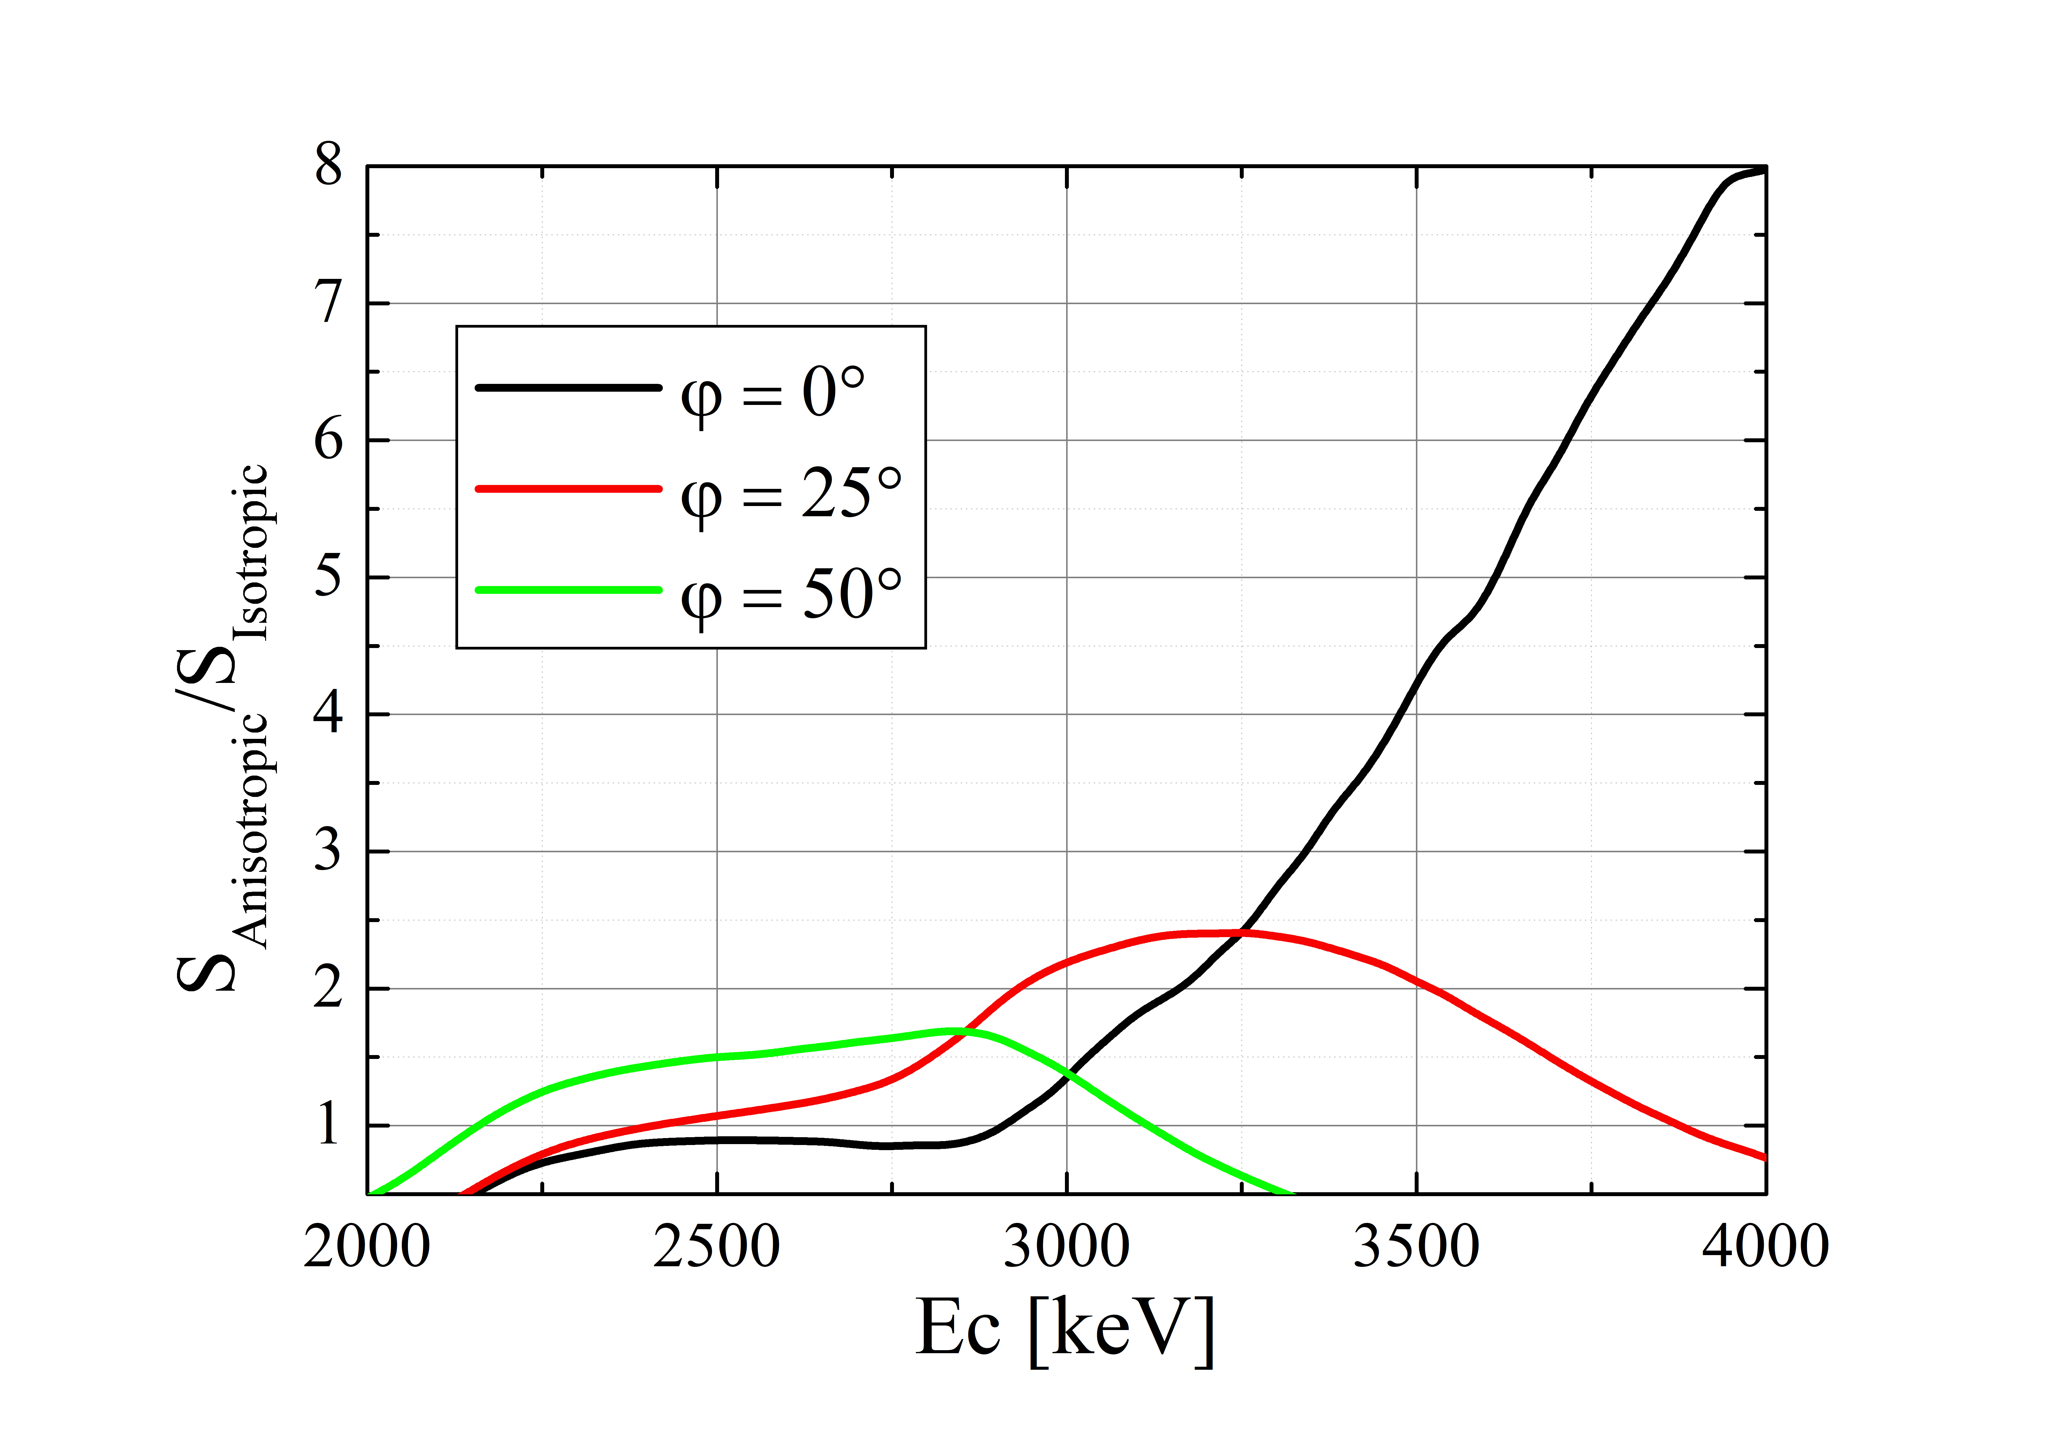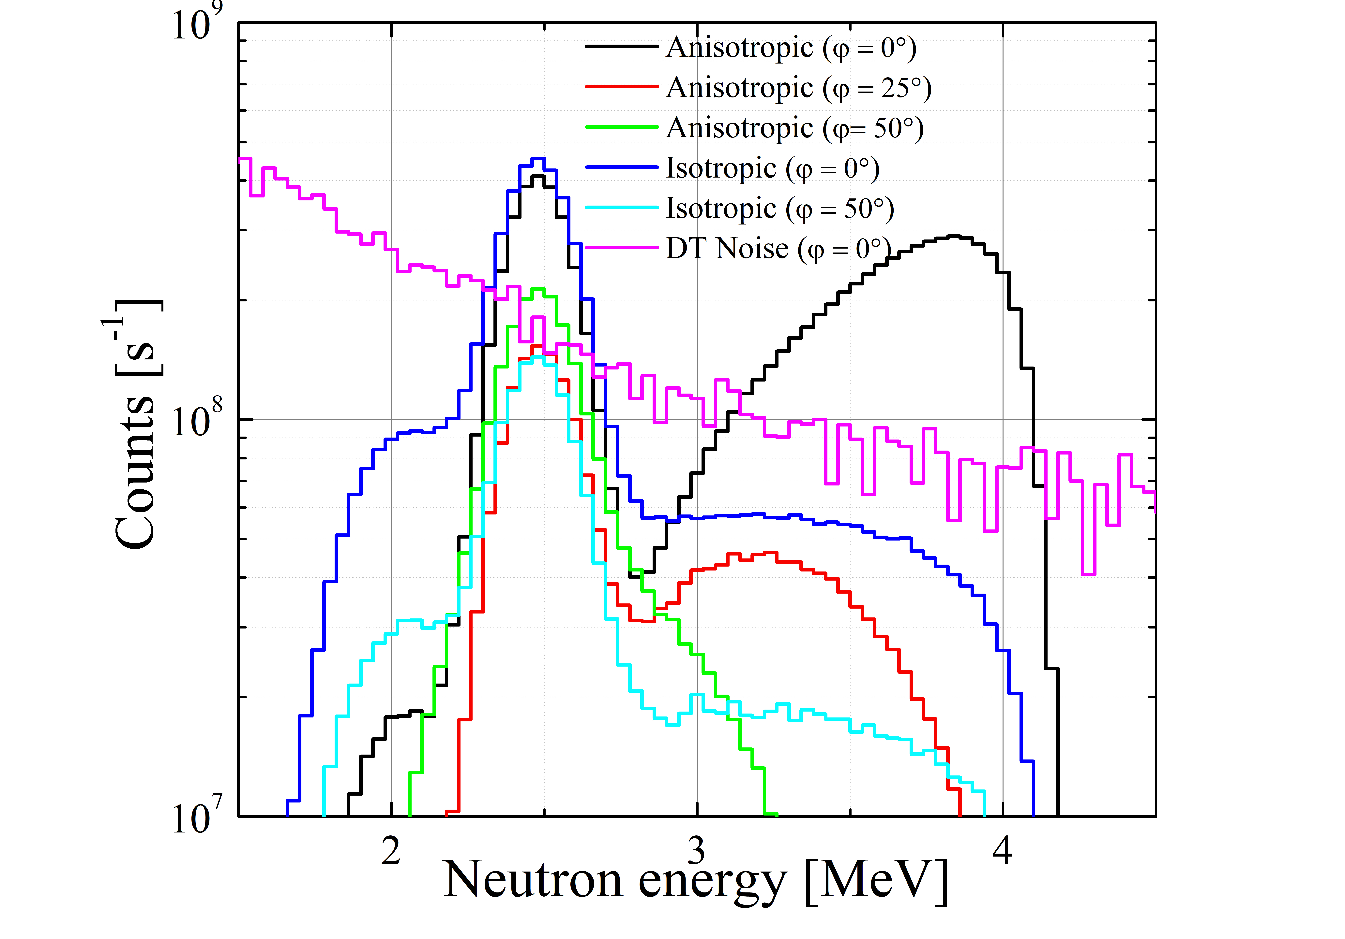Fig. 5 shows incident neutron spectrum on the detector. (φ = 0°, 25°, 50°). And, the incident spectrum obtained under the assumption of isotropic emission (φ = 0°, 50°) and the slowing down component of DT neutrons (φ = 0°) is also shown. Since the emission spectrum around the NBI incident direction is measured, the ratio of energetic neutron increases as φ increase. In particular, when φ = 0°, the peak appears in the high energy region (around 4.0 MeV). This peak is as large as Gaussian formed by thermonuclear reaction. Fig. 6 shows improvement of count due to anisotropic. Now, count is the integral value in the range of Ec±240 keV. Depending on the collimator direction, φ, the measurement energy region where count is improved differs. In the case of φ = 50°, count is improved about 50% in the 2.4-2.5 MeV region. On the other hand, in the case of φ = 45°, count is improved about 8.0 times in the high energy region (around 4.0 MeV). And, the intensity of the incident spectrum obtained under the assumption of isotropic emission is different between φ = 0° and φ = 50° due to the effect of line of sight. It can be confirmed that the above results are appropriate from the influence of the collimator direction on the intensity of neutron flux and the S/N value discussed in Ref. [7].
Fig. 6 Improvement of count
due to anisotropic
Fig. 5 incident neutron spectrum
on detector
3-2 Improvement of S/N value and distinction of Signal and Noise
Fig. 7 shows S/N value obtained for each incident spectra of Fig.5. Now S/N value is given by
$$\frac{S}{N}= \frac{\int_{Ec-240 keV}^{Ec+240 keV}{F_{DD}\left(E\right)dE}}{\int_{Ec-240 keV}^{Ec+240 keV}{F_{DT}\left(E\right)dE}} , (5)$$
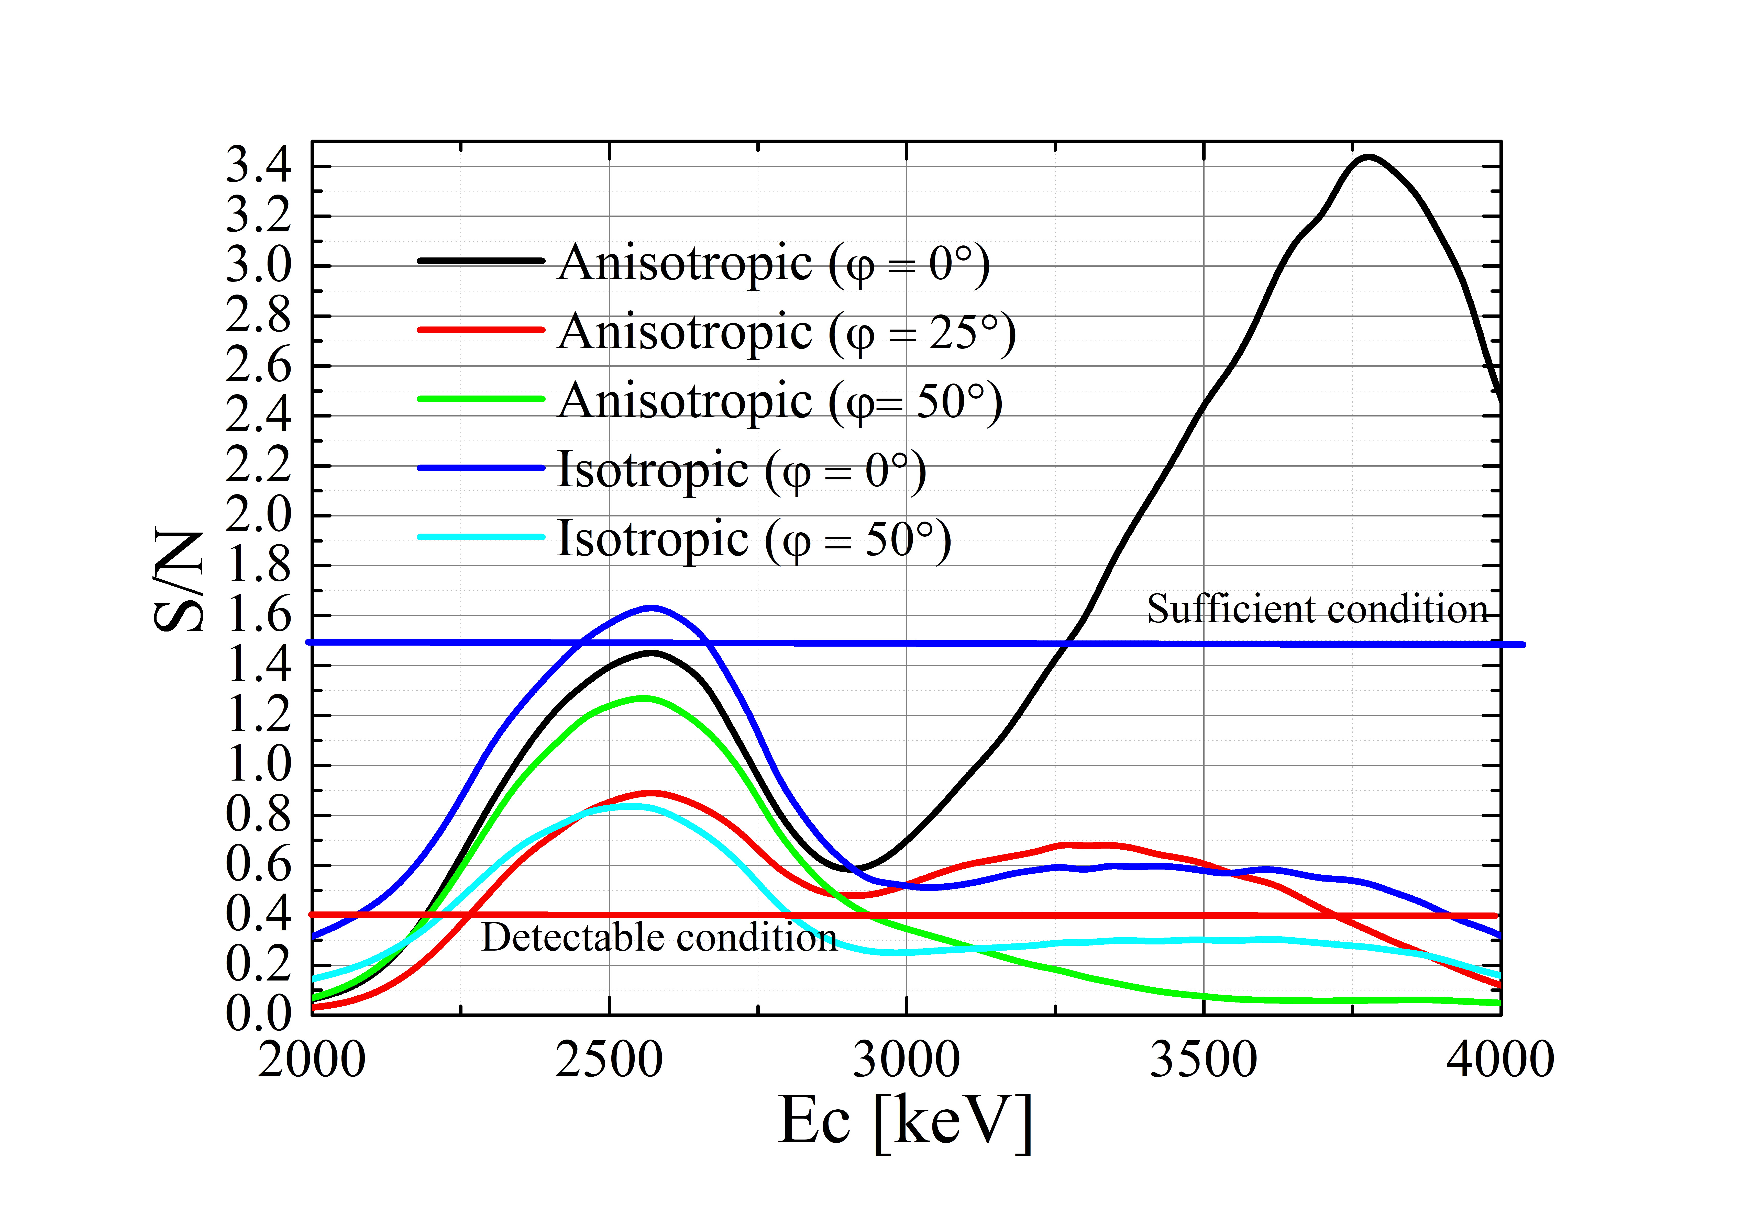where F_{DD(DT)} is incident DD (DT) neutron energy spectrum on the detector.
In Ref. [17], DD neutron and Slowing down component of DT neutron can be distinguished when S/N> 0.4. But, in this case, high accuracy is required for both of Signal and Noise measurements to decide each spectrum. On the other hands, in Ref. [5], it has been pointed out that DD neutrons can be confirmed sufficiency when S/N≫1.0. Thus, for the above reasons, we defined S/N > 1.5 as 'sufficient condition' and S/N > 0.4 as 'detectable condition' in fuel ion ratio diagnostic.
Fig. 7 S/N value dependency on
measurement energy range
In the case of measuring neutron emission spectrum of Fig. 3 (Ti = 10 keV, nt/nd = 1.0), S/N > 0.4 can be achieved regardless of the collimator direction, φ. S/N > 1.5 can be achieved regardless of the anisotropic consideration when φ = 0°. In addition, S/N > 3.0 can be achieved considering anisotropic (φ = 0°) and measuring high energy region (around 4.0 MeV). Thus, the measurement of the anisotropic emission spectrum showed that the S/N was improved about twice. It was shown that ‘sufficient condition’ is achieved in the ITER class plasma.
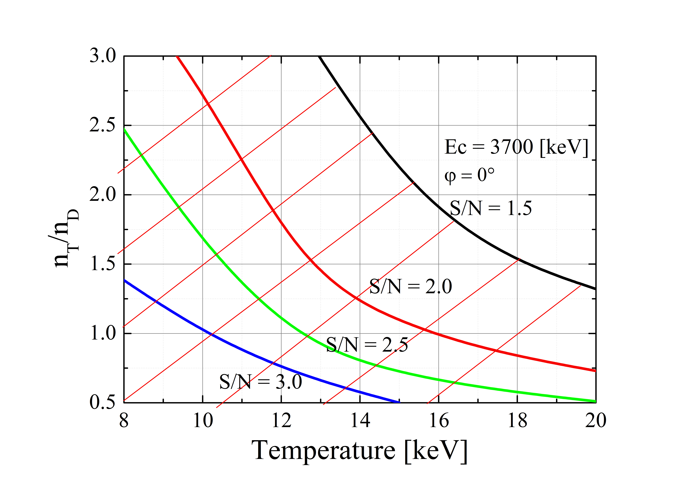3-3 Detectable plasma parameter range
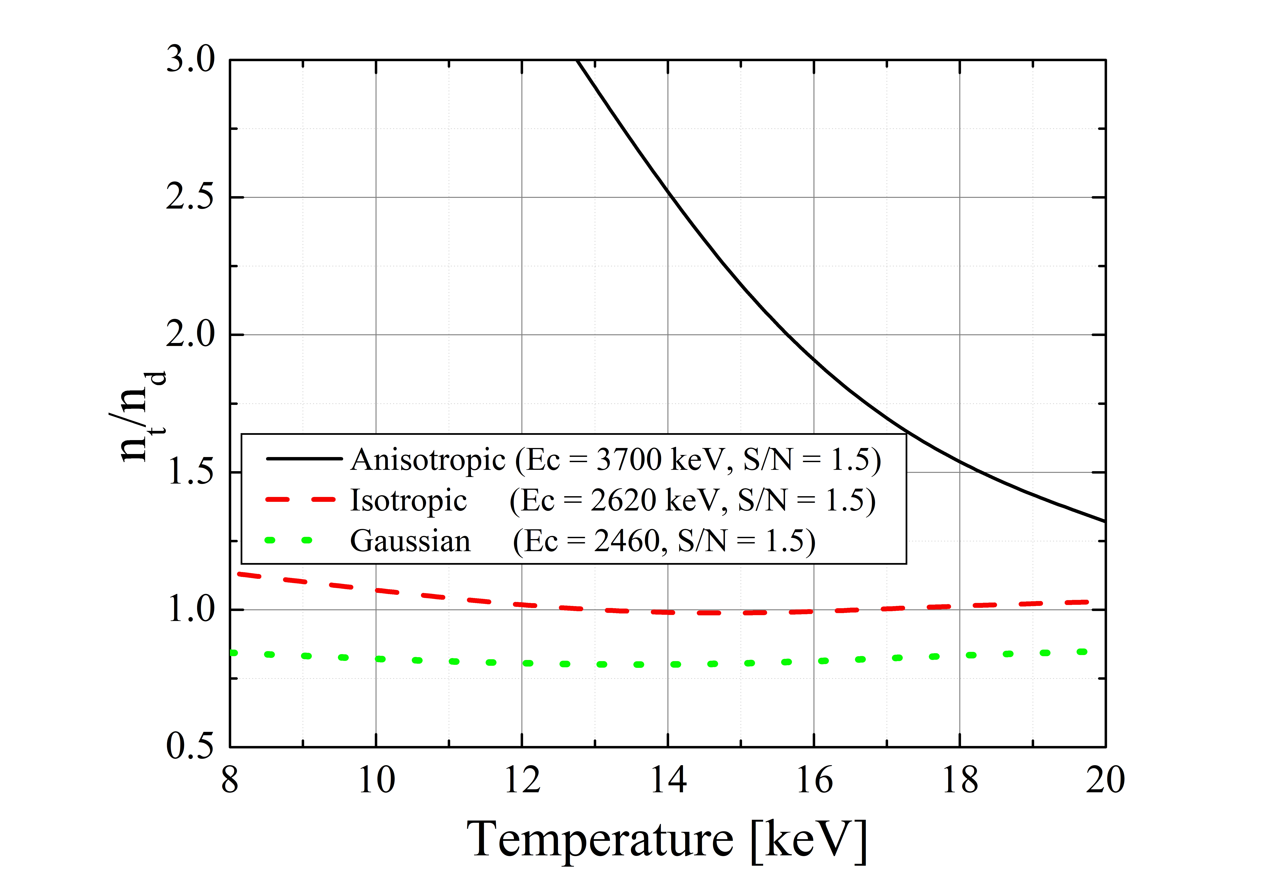Fig. 8 shows S/N values at various ion temperature and fuel ion ratio for anisotropic emission spectrum measurement (Ec = 3700 keV). The diagonal line in Fig. 7 indicates the region where S/N > 1.5. Due to anisotropic consideration, the parameter range of sufficient condition is n_{T}/n_{D} < 1.2 and Ti < 20 keV. In addition, it was shown to achieve detectable condition (S/N > 0.4) even when n_{T}/n_{D} ≒ 3.0. This suggests that the fuel ion ratio diagnosis using neutron diagnostic is valid over the entire ITER operating range.
Fig. 8 S/N value at various
plasma parameter
Fig. 9 shows the detectable plasma parameter range under sufficient condition. The solid line shows S/N value (= 1.5) at various plasma parameters for anisotropic emission spectrum measurement. The dashed and dotted lines indicate that obtained when measuring the isotropic emission spectrum and the Gaussian distribution, respectively. Due to anisotropic consideration, parameter range to satisfy the condition is expanded. In particular, the S/N value is well improved in the high n_{T}/n_{D} region. Focusing on the modification from Gaussian reduces the effect of deuteron density reduction on neutron emission rate. These result shows that consideration of anisotropy is effective.
Fig. 9 S/N value using various method
- Conclusion remarks
In this study, we evaluated the improvement of n_{T}/n_{D} density ratio measurement by anisotropic emission spectrum measurement. When the installation direction of the collimator was set to φ = 0 ° (tangential line), it was found that there was a measurement region where the number of incident neutrons increased by a maximum of about 8 times compared to the assumption of isotropic emission. As a result, the S/ N value was doubled compared to the isotropic emission spectrum measurement in the case of Ti = 10 keV, nt/nd = 1.0. And, due to anisotropic neutron emission spectrum measurement, the parameter range of sufficient condition (S/N > 1.5) is n_{T}/n_{D} < 1.25 and Ti < 20 keV. In addition, it was shown to achieve detectable condition (S/N > 0.4) even when n_{T}/n_{D} ≒ 3.0. Therefore, measurement of anisotropic emission spectrum is effective for improving performance of fuel ion ratio diagnosis.
In future work, we need to discuss the plasma parameter range that can be measured in more detail considering the performance of the detector (response function, detection efficiency, etc.). And, discussion of electron density dependence is also needed. In addition, at high n_{T}/n_{D}, precise calculation of DT slowing-down component by neutron transport calculation is required because of 0.4 < S/N <1.0. Thus, it is also important to improve the accuracy of nuclear data when considering the feasibility of fuel ion ratio diagnostic. And, it is also necessary to study the practicality of this method in the nuclear fusion DEMO reactor.
Reference
[1] G. Ericsson, et al., Rev. Sci. Instrum. 81, 10D324 (2010).
[2] V. G. Kiptily, Nucl. Fusion, 55, 023008 (2015)
[3] Luhmann N. C. et al., Fusion Sci. Technol. 53, 335-96 (2008)
[4] L. Bertalot, et al., JINST, 7, C04012 (2012)
[5] J. Kallne, et al., Rev. Sci. Instrum. 62, 2781 (1991).
[6] S. B. Korsholm, et al., Rev. Sci. Instrum. 81, 10D323 (2010).
[7] P. Antozzi, et al., Nucl. Instrum. METH A, 368, 457-472 (1996).
[8] Y. Kwamoto, et al., J. Plasma Fusion Res. 11, 2405078 (2016).
[9] H. S. Bosch and G. M. Hale, Nucl. Fusion, 32, 611-631 (1992)
[10] H. Matsuura, et al., J. Plasma Fusion Res. 9, 48-53 (2010)
[11] M. Drosg and O. Schwerer, Production of monoenergetic neutrons between 0.1 and 23 MeV: neutron energies and cross-sections, Handbook of Nuclear Activation Data (Vienna: IAEA) STI/DOC/10/273, ISBN 92-0-135087-2 (1987).
[12] John D. Gaffey, Jr., J. Plasma Phys. 16, 149-169 (1976)
[13] M. E. Swan et al., Proceedings of the 22nd IEEE / NPSSS symposium on Fusion Engineering,
Albuquerque, HM. June 17-21, 1 (2007)
[14] K. Okada, et al., 32nd EPS Conference on Plasma Phys. Tarragona, 27 June - 1 July 2005 ECA
Vol.29C, P-4.096 (2005)
[15] Y. Nagaya et al., JAERI 1348 (2005)
[16] K. Shibata, et al., J. Nucl. Sci. Technol. 48, 1–30 (2011).
[17] J. Kallne,s et al., Rev. Sci. Instrum. 68, 581 (1997)

