The Influence of B and Li Burnable Poison on
Effective Multiplication Factor in the HTGR

Yuki Koga¹, Hideaki Matsuura¹
¹Department of Applied Quantum Physics and Nuclear Engineering, Kyushu University,
744 Motooka Nishi-ku, Fukuoka, 319-0395 Japan
e-mail: Koga_yuki@nucl.kyushu-u.ac.jp

Tritium is required for the engineering tests and the initial DEMO fusion reactor. In order to establish a tritium supply method, tritium production using the high temperature gas-cooled reactor (HTGR) was proposed. The B burnable poison (BP) is replaced with Li for tritium production. Li is loaded as a solid unit called Li rod. There is a possibility that difference in an effective multiplication factor (k_{eff}) arises by using Li instead of B. The k_{eff} difference in the HTTR is evaluated and discussed. The same evaluation is also conducted for the GTHTR300. It is revealed how the difference appears and how the HTGR types influence on the results.

- Introduction
A fusion reactor using T(d,n)α reaction requires tritium for its R&D. Tritium is produced artificially because it hardly exists in nature, while deuterium is obtained from water. Approximately 400 g of tritium is burned per day in a 3 GW thermal output power. A sufficient amount of initial tritium is required to start up a fusion reactor. It was reported that this amount of tritium for the Demo reactor was several 100 g -approximately 27 kg [1,2]. In addition, 100 g or more of tritium is required for an engineering test using tritium before construction of DEMO reactors. The tritium consumed on a fusion reactor for the ITER project has been produced by using the Canadian Deuterium Uranium reactors, although it has not been clarified that the way to supply tritium for the initial DEMO reactors, in particular Japan. Therefore, we proposed a tritium production method using the high temperature gas-cooled reactor (HTGR) [3] by loading a Li compound as a burnable poison (BP). The HTGR is composed by mainly graphite (moderator) and He (coolant). They are chemically stable and do not react with the Li compound. An enough amount of Li can be loaded into the HTGR without ⁶Li concentration. It is because the HTGR core size is larger than other types of fission reactor. Normal BP (B rod) is a cylindrical B₄C and solid states so that Li compound is loaded as same shape without significantly changing the original core design. We consider Li compound is loaded as Li rod. The Li rod includes LiAlO₂ in a cylindrical alumina case with Ni coated Zr pebbles (tritium absorber) [4]. It can produce and contain tritium during the operation time. We are planning an irradiation test on the High Temperature engineering Test Reactor (HTTR) [5] in order to confirm the Li rod performance and to demonstrate the tritium production on the HTGR [6].
The absorption cross-sections and loaded amounts are different in Li and B. Accordingly Li rod reactivity may be different from B rod and the HTGR characteristic may be changed by loading Li rods. In order to operate the HTGR loaded Li rods, it needs to clarify the characteristic change. The purpose of this paper is the evaluation and discussion of the HTGR reactor characteristic difference in the B rod and the Li rod. The effective multiplication factors (k_{eff}) during operation are evaluated as the reactor characteristics. We selected the HTTR with 30 MW thermal output [5] and the Gas Turbine High Temperature Reactor 300 (GTHTR300) with 600 MW thermal output [7] for the evaluation. The HTGR characteristic difference by the BP change is also discussed for the two reactors.

- Analysis model
We assumed the original designs of the B rod for the evaluation. Fig.1 shows the designs of the B rod for the HTTR [8] and GTHTR300 [7]. We designed the Li rod to fit each BP hole sizes. Fig.2 shows the Li rod design for the HTTR. Its diameter is 14 mm, height is 450 mm, Al₂O₃ layer thickness is 1.9 mm, Zr layer thickness is 0.1 mm, LiAlO₂ thickness is 2.7 mm and hollow radius is 2.3 mm respectively. The hollow inside the Li rod is full of Zr pebbles coated Ni which diameter is 1 mm. Fig.3 shows the Li rod design for the GTHTR300. Its diameter is 44 mm, height is 950 mm, Al₂O₃ layer thickness is 6.3 mm, Zr layer thickness is 1 mm, LiAlO₂ thickness is 2.5 mm and hollow radius is 12.2 mm respectively. The hollow is full of the same Zr pebbles coated Ni.
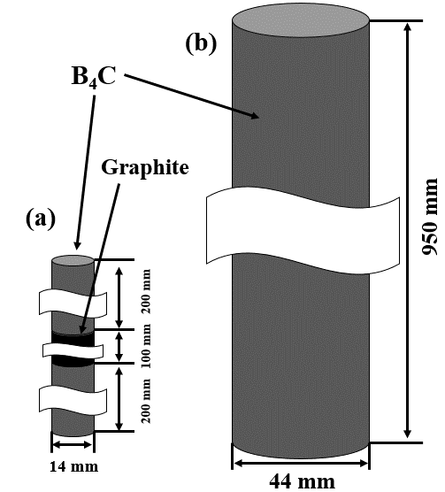
Fig.1. A schematic view of the normal B rods for the HTTR (a) and the GTHTR300 (b).

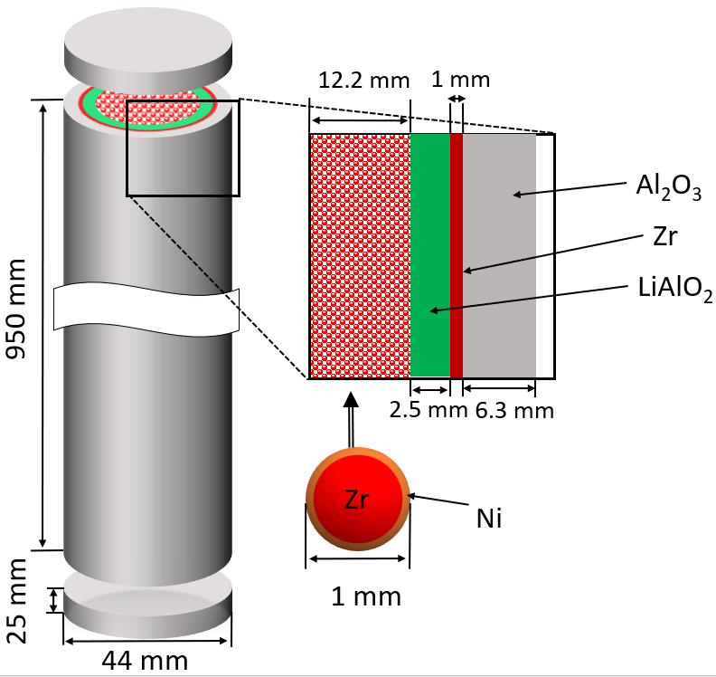
Fig.3. A schematic view of the Li rod for the GTHTR300

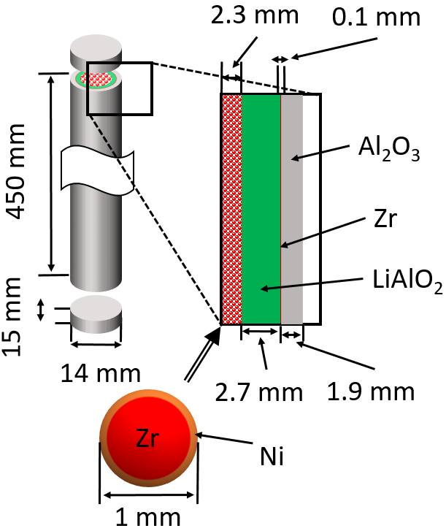
Fig.2. A schematic view of the Li rod for the HTTR.

In order to evaluate k_{eff} and the cumulative weight of produced tritium, we conducted nuclear burning calculations using the continuous-energy Monte Carlo transport code MVP-BURN [9,10] with a nuclear data JENDL-4.0 [11]. We assumed a HTTR core system with the B rods or 450 the Li rods and a GTHTR300 core system with the B rods or 2160 the Li rods. The operation period in these calculations is 360 days and all control rods were assumed to be pulled out. We set the time steps in the calculations were 0, 1, 5, 30, 60, 120, 180 and 360 days. 600,000 neutrons were generated for each the time steps. The statistical error of k_{eff} were less than 0.1 % in the all calculation, which is sufficient accuracy. Zr was not included in those calculations because Zr does not influence on k_{eff} and tritium production by its cross-section.

- Results and discussion
Fig.4 shows the accumulative produced tritium and k_{eff} (B and Li rod) by the operation time for the HTTR. The k_{eff} maintained nearly 1.05 during the operation when the B rods were loaded, which corresponded with the k_{eff} in the reference [5]. This is because the B rods suppress excessive reactively by burning of ¹⁰B atoms inside them in the early period of operation, and the B rods decrease their minus reactively in the latter period of operation. The k_{eff} decreased straightly during the operation when Li rods were loaded and produced 30.3 g of tritium in 360 days. ⁶Li atoms in the Li rods are not burned quicker than ¹⁰B atoms and remain more in the late time of operation, because the cross-section of ⁶Li is 940 b for thermal neutron whereas that of ¹⁰B is 3837 b for it. The k_{eff} decreased immediately after the operation starts in the both of those calculations, by Xe generates.
The accumulative produced tritium and k_{eff} (B and Li rod) by the operation time for the GTHTR300 is shown in Fig.5. When the B rods were loaded, the k_{eff} increased until 360 days because the design of the GTHTR300 is assumed 2 years continuous operation. It was same tendency to the reference [7]. When the Li rods were loaded, the k_{eff} decreased straightly as well as in the case for the HTTR and they produced 818 g of tritium. However, the difference of k_{eff} by the BP change during the operation for GTHTR300 was more than that for HTTR. It means there is more neutron to suppress by control rod in the GTHTR300 operation.
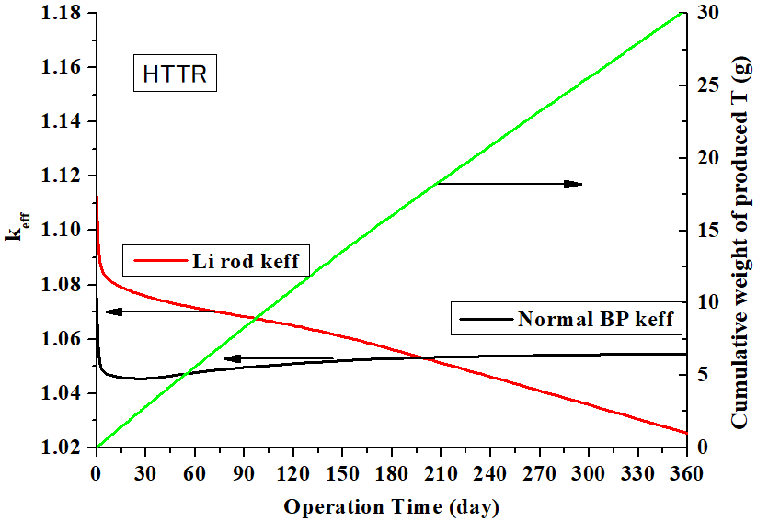
Fig.4. The accumulative produced T and k_{eff}
by the operation time for the HTTR.
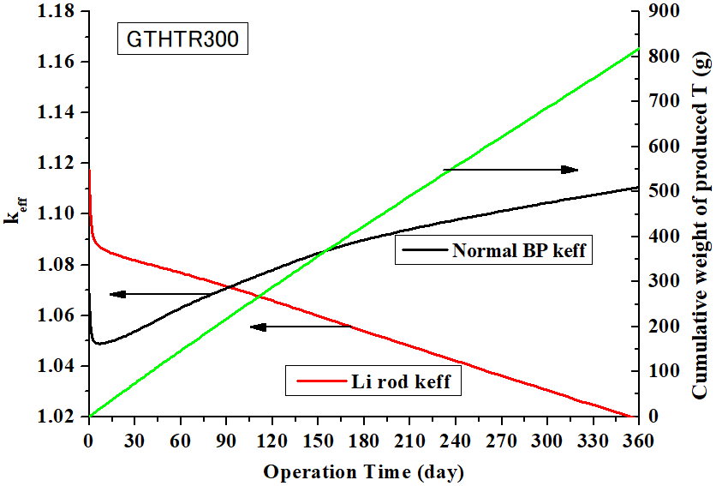
Fig.5. The accumulative produced T and k_{eff}
by the operation time for the GTHTR300.

At first we confirmed the amount of loaded LiAlO₂ and the volume of a fuel block in Table 1 to investigate this reason. The amount of loaded LiAlO₂ into the GTHTR300 is about 7 times of that into the HTTR in order to produce 800 g of tritium, while the difference of fuel block volume is smaller. Therefore, the Li/Block volume ratio for the GTHTR300 is about 9 times of that for the HTTR. The increase of the ratio decreases ⁶Li burnability by self-shielding effect when the LiAlO₂ shapes are same.

Table 1. The amount of loaded LiAlO₂ into The HTGRs.
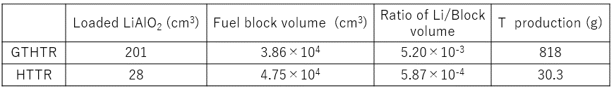
Next, we analyzed the outputs of the nuclear burning calculations. Fig.6 shows the amount of burned BP atoms by the operation time. ¹⁰B atoms were burned quicker than ⁶Li for both of the HTGRs in those calculations, which fits to the above theory. The amount of burned ⁶Li atoms for the HTTR was about 10 mol and almost same to that of ¹⁰B atoms (the difference is about 3 %). On the other hand, the amount of burned ⁶Li atoms for the GTHTR300 was about 270 mol and more than that of ¹⁰B atoms, which difference is about 21 %. It was caused by loading large amount of LiAlO₂ to produce maximum tritium in the GTHTR300. Fig.7 shows the ratio of remained BP by the operation time. When the B rods are loaded, the remain ratio of the HTTR was 28 %. It was more than that of the GTHTR300 slightly. The reason is two B rods are loaded into each HTTR fuel blocks while three B rods are loaded into those of the GTHTR300. ¹⁰B atoms in the HTTR is less burn than that in the GTHTR300 by the increase of Li heterogeneous. when the Li rods were loaded, the remain ratio of the GTHTR300 was 75 %, whereas the ratio of the HTTR was 69 %. It follows the relation of the Li/Block volume ratio between ⁶Li burnability by self-shielding effect. Therefore, excessive load and low burnability of ⁶Li on the GTHTR300 makes the k_{eff} during the operation bad by neutron efficiency reduction.
It was reported that the GTHTR300 has potential to produce additional 40 % amount of tritium which the Li rods can produce [12]. However, it does not show the way to improve the k_{eff} but one to increase the amount of produced tritium. The decrease of Li heterogeneous can improve the k_{eff} and the remain ratio because self-shielding effect is weakened and ⁶Li becomes more burnable. Loading many smaller Li rods is one of the solutions to reduce Li heterogeneous. We conducted a model calculation under the assumption that ⁶Li was mixed into the GTHTR300 fuel blocks so as to show the improvement example. Fig.8 is the accumulative produced tritium and k_{eff} by the operation time for the GTHTR300 under this assumption. 4718 g of ⁶Li was mixed into the fuel blocks in this calculation (All the Li rods for it included 6673 g of ⁶Li). The k_{eff} during the operation maintained nearly 1.05 until 180 days, which was similar to the case that B rods were loaded. The ratio of remained ⁶Li was 63 % consequently the amount of produced tritium achieved 873 g.
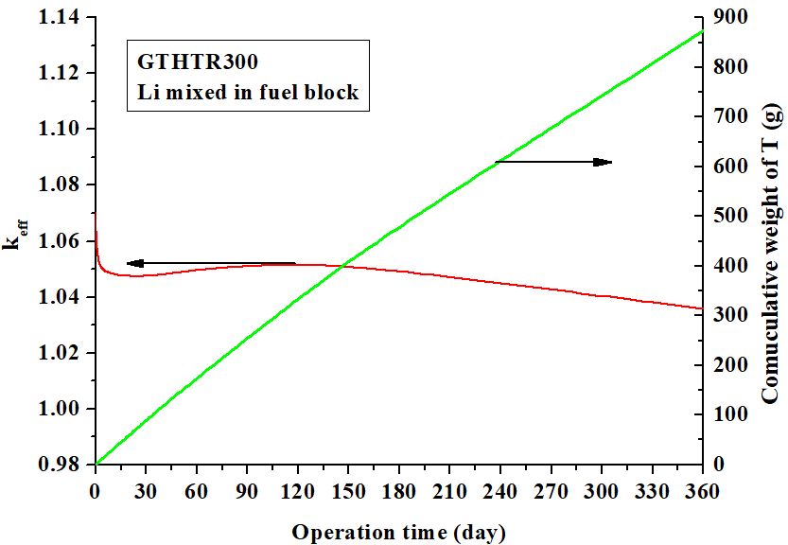
Fig.8. The accumulative produced T and k_{eff} by the operation time
for the GTHTR300 under the assumption Li are mixed in the fuel blocks.
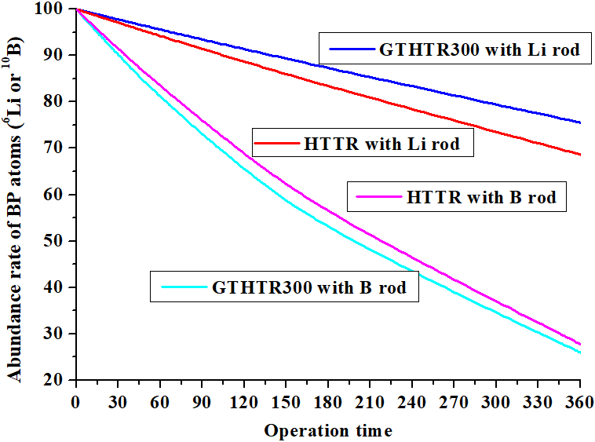
Fig.7. The ratio of remained BP
by the operation time.
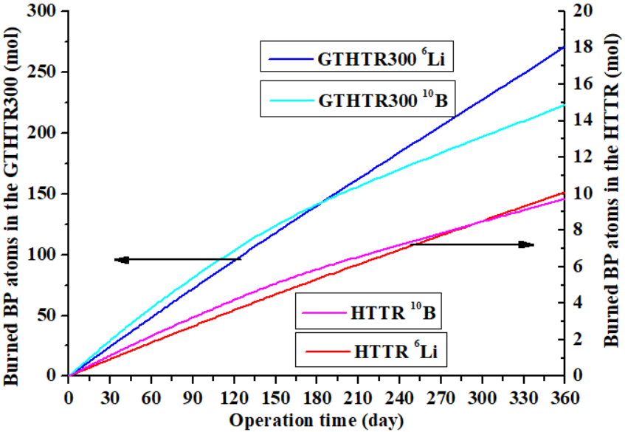
Fig.6. The amount of burned BP atoms
by the operation time.

- Conclusion remarks
We evaluated effective multiplication factors (k_{eff}) during operation of the HTTR and the GTHTR300 for the evaluation and discussion of the HTGR reactor characteristic difference in the B rod and the Li rod. The k_{eff} kept up to a value or increased during the operation when the B rods were loaded into the HTGRs. The k_{eff} decreased straightly during the operation when Li rods were loaded for tritium production because ⁶Li atoms are not burned quicker than ¹⁰B atoms and more remain in the late time of operation.
The excessive load of LiAlO₂ to produce 800 g of tritium using the GTHTR300 increases more the difference of k_{eff} by the BP change than that using the HTTR to produce 30 g of tritium. The GTHTR can improve its k_{eff} characteristic by decrease Li heterogeneous, which reduces the amount of loaded LiAlO₂ and increases ⁶Li burnability.

References
[1] R. Hiwatari, J Atomic Energy Society Japan [in Japanese] 60 (8) (2018) 52-56.
[2] Y. Asaoka., et al., Fusion Tech. 30 (1996) 853-863.
[3] H. Matsuura, et al., Nucl. Eng. Des.243(2012) 95-101.
[4] H. Matsuura, et al., Fusion Eng. Des. 146 (2019) 1077-1081.
[5] S. Saito, et al., JAERI 1332 (1994).
[6] Y. Koga, et al., Fusion Eng. Des. 136 (2018) 587-591.
[7] T. Nakata, et al., JAERI-Tech (2002) 2002-066.
[8] N. Fujimoto and N. Nojiri, JAERI-Technology (2006) 2005-008.
[9] Y. Nagaya, et al., JAEA-Data/Code (2017) 2016-019.
[10] K. Okumura, et al., J. Nucl. Sci. Tech., 37 (2000), 128-138.
[11] K. Shibata, et al., J. Nucl. Sci. Technol. 48(1) (2011) 1-30.
[12] S. Nagasumi et al., Spring Meeting of AESJ (2016) 2L06.

