Production cross sections of ⁴⁵Ti via deuteron-induced reaction on ⁴⁵Sc

Tsoodol ZOLBADRAL^{1,2*}, Masayuki AIKAWA^{1,3}, Dagvadorj Ichinkhorloo^{2,3}, Khishigjargal TEGSHJARGAL⁴, Yukiko KOMORI⁵, Hiromitsu HABA⁵, Sándor TAKÁCS⁶, Ferenc DITRÓI⁶, Zoltán SZŰCS⁶

¹ Graduate School of Biomedical Science and Engineering, Hokkaido University, Sapporo 060-8638, Japan
² Nuclear Research Center, National University of Mongolia, Ulaanbaatar 13330, Mongolia
³ Faculty of Science, Hokkaido University, Sapporo 060-0810, Japan
⁴ School of Engineering and Applied Sciences, National University of Mongolia, Ulaanbaatar 14201, Mongolia
⁵ Nishina Center for Accelerator-Based Science, RIKEN, Wako 351-0198, Japan
⁶ Institute for Nuclear Research (ATOMKI), 4026 Debrecen, Hungary
*E-mail: zolbadral@nds.sci.hokudai.ac.jp

Production cross sections of the medical radionuclide ⁴⁵Ti with the deuteron-induced reactions on ⁴⁵Sc were investigated. The stacked foil activation method and γ-ray spectrometry were used. The physical yield of ⁴⁵Ti was deduced from the measured cross sections. Our results are consistent with previous experimental data.

- Introduction
The radinuclide ⁴⁵Ti has a half-life of 184.8 min and is a positron emitter ($E_{max}=$ 1040 keV, $E_{ave}=$ 439 keV, $I_{β^{+}}=$ 84.8%) [1]. The emitted positrons followed its decay are suitable for positron emission tomography (PET) [2]. The deuteron-induced reaction on a ⁴⁵Sc target is a possible route to produce this radionuclide at cyclotrons. However, only one experimental study [3] on the cross sections of the ⁴⁵Sc(d,2n)⁴⁵Ti reaction is available in the literature. Therefore, we measured the cross sections of the ⁴⁵Sc(d,2n)⁴⁵Ti reaction.

- Experimental methods
The experiment was performed at the AVF cyclotron of the RIKEN RI Beam Factory. The stacked-foil activation technique and γ-ray spectrometry were adopted to measure the cross sections.
The stacked target consisted of metallic foils of ⁴⁵Sc (25 μm thick, 99.0% purity, Nilaco Corp., Japan and 250 μm thick, 99.9% purity, Johnson Matthey Alfa Products company, USA), ²⁷Al (99.6% purity, Nilaco Corp., Japan) and ^{nat}Ti (99.6% purity, Nilaco Corp., Japan). The size and weight of the foils were measured to determine the average thicknesses of the foils. The derived thicknesses were 7.71 and 76.0 mg/cm² for ⁴⁵Sc, 4.99 mg/cm² for ²⁷Al and 9.13 mg/cm² for ^{nat}Ti, respectively. The foils were cut for the size of 8×8 mm to fit a target holder served also as a Faraday cup.
The target was irradiated for 30 min with a 24-MeV deuteron beam. The incident beam energy was measured by the time-of-flight method [4]. The energy degradation in the stacked target was calculated by the SRIM code [5]. The beam intensity was determined by collecting the charge in the Faraday cup. γ-rays were measured for each irradiated foil by a high-resolution HPGe detector. The detector was calibrated by a mixed standard γ-ray point source. The dead time was kept less than 7% in the measurements.
The cross sections of the ^{nat}Ti(d,x)⁴⁸V monitor reaction were used to assess the beam parameters. The cross sections were derived from measurements of the 983.5-keV γ-ray (I_{γ} = 99.98%) emitted with the ⁴⁸V decay (T_{1/2} = 15.9735 d), and the result was compared with the IAEA recommended values [6]. The beam intensity measured by the Faraday-cup was decreased by 3.0 % to have good agreement among the derived and the recommended excitation function of the ^{nat}Ti(d,x)⁴⁸V reaction (Fig. 1). The corrected beam intensity (175.2 nA) was adopted in the data assessment for the cross sections.

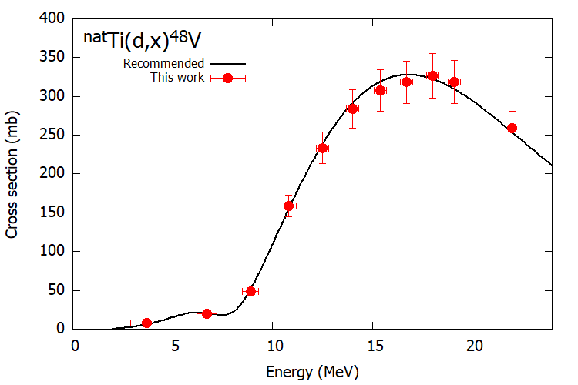
Fig. 1. The excitation function of the ^{nat}Ti(d,x)⁴⁸V monitor reaction compared with the recommended values [6].

- Results and Discussion
The cross sections of the ⁴⁵Sc(d,2n)⁴⁵Ti reaction were derived from the measurement of the 719.6-keV γ-ray ($I_{γ}$ = 0.154 %) emitted in the decay of ⁴⁵Ti, and are shown in Fig. 2 in comparison with the previous data [3] and the theoretical estimation of TENDL-2017 [7]. Our result is consistent with the previous data. The peak position of the TENDL-2017 data [7] is slightly shifted to the lower energy than those of the two experimental datasets.
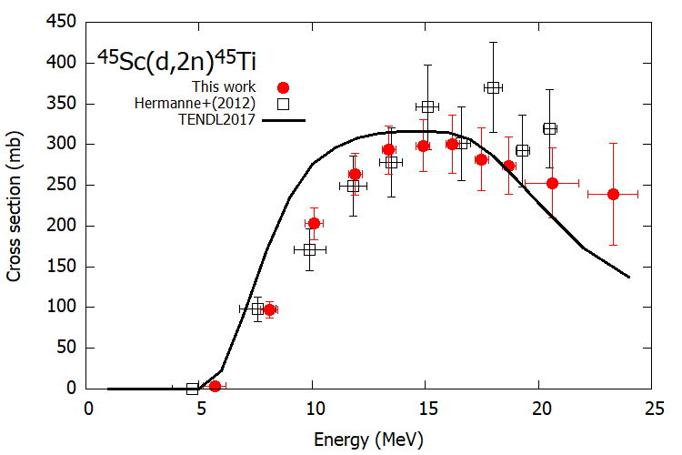

Fig. 2. Excitation function of the ⁴⁵Sc(d,2n)⁴⁵Ti reaction.
The physical yield of ⁴⁵Ti was deduced from a spline fitted curve of the measured excitation function and stopping power calculated using the SRIM code [5]. The derived yield is shown in Fig. 3 in comparison with the only experimental data [8]. The present yield curve of ⁴⁵Ti is slightly larger than the experimental data at 22 MeV [8].
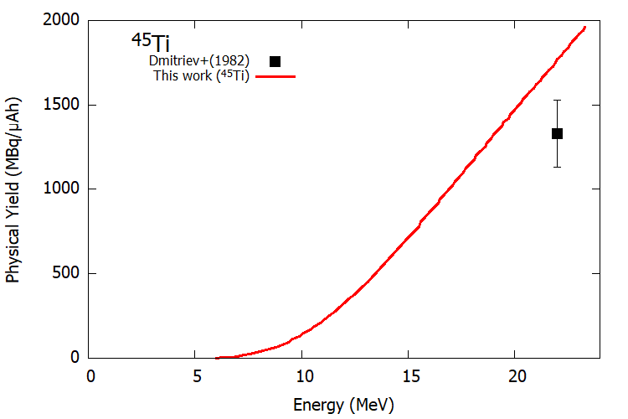
Fig. 3. Physical yield of ⁴⁵Ti via the deuteron-induced reactions on ⁴⁵Sc.

There are no isotopic impurities produced below 15.3 MeV, which is the threshold energy of the ⁴⁵Sc(d,3n)⁴⁴Ti reaction. Production of ⁴⁵Ti without radio-contamination is possible by using the ⁴⁵Sc(d,2n)⁴⁵Ti reaction in the energy range from 15 to 5 MeV. Only the stable ⁴⁶Ti is co-produced in the (d,n) reaction in comparable quantity by the prediction based on the cross section of the (d,n) reaction taken from the TENDL-2017 data library.

- Conclusion
The excitation function of the ⁴⁵Sc(d,2n)⁴⁵Ti reaction was measured up to 24 MeV. The stacked-foil activation technique and the high-resolution γ-ray spectrometry were used for the cross section measurements. The obtained data were compared with the previous experimental data and the TENDL-2017 data. The derived excitation function of the ⁴⁵Sc(d,2n)⁴⁵Ti reaction is consistent with the data of Hermanne et al. (2012). The physical yield deduced from measured cross sections is slightly larger than the experimental data of Dmitriev et al. (1983). The production of radioactive-contamination-free ⁴⁵Ti can be obtained via the ⁴⁵Sc(d,2n)⁴⁵Ti reaction using cyclotrons in the energy region below 15 MeV.

Acknowledgements
The experiment was carried out at RI Beam Factory operated by RIKEN Nishina Center and CNS, University of Tokyo, Japan. This work is supported by JSPS KAKENHI Grant Number 17K07004. Ts.Z was granted a scholarship by the M-JEED project (Mongolian-Japan Engineering Education Development Program, J11B16).

References
[1] National Nuclear Data Center. Nuclear structure and decay data on-line library, Nudat 2.7 [Internet]. 2017. Available from: http://www.nndc.bnl.gov/nudat2/
[2] Vavere AL, Laforest R, Welch MJ. Production, processing and small animal PET imaging of titanium-45. Nucl. Med. Biol. 2005;32:117–122.
[3] Hermanne A, Adam Rebeles R, Tarkanyi F, et al. Cross sections of deuteron induced reactions on ⁴⁵Sc up to 50 MeV: Experiments and comparison with theoretical codes. Nucl. Instruments Methods Phys. Res. Sect. B Beam Interact. with Mater. Atoms. 2012;270:106–115.
[4] Watanabe T, Fujimaki M, Fukunishi N, et al. Beam energy and longitudinal beam profile measurement system at the RIBF. Proc. 5th Int. Part. Accel. Conf. (IPAC 2014). 2014. p. 3566–3568.
[5] Ziegler JF, Ziegler MD, Biersack JP. SRIM - The stopping and range of ions in matter (2010). Nucl. Instruments Methods Phys. Res. Sect. B Beam Interact. with Mater. Atoms. 2010;268:1818–1823.
[6] Hermanne A, Ignatyuk A V., Capote R, et al. Reference Cross Sections for Charged-particle Monitor Reactions. Nucl. Data Sheets. 2018;148:338–382.
[7] Koning AJ, Rochman D, Sublet JC, et al. TENDL: Complete Nuclear Data Library for Innovative Nuclear Science and Technology. Nucl. Data Sheets. 2019;155:1–55.
[8] Dmitriev PP, Krasnov NN, Molin GA. Yields of radioactive nuclides formed by bombardment of a thick target with 22-MeV deuterons. INDC(CCP)-210; 1983. p. 1–8.

