Recent progress and future plan on the JENDL project

Osamu IWAMOTO
Nuclear Data Center, Japan Atomic Energy Agency
Tokai-mura, Naka-gun, Ibaraki-ken 319-1195 Japan
e-mail: iwamoto.osamu@jaea.go.jp

The JENDL project has been developing evaluated nuclear data libraries to meet the needs of nuclear science and engineering. JENDL provides general and special purpose files generally for nuclear reactor applications and topically for other applications that cannot be covered by the general purpose file, respectively. Owing to the broadened needs of the nuclear data, many special purpose files have been released since 2010 in which JENDL-4.0 was released. Concerning the general purpose file, development of the next version JENDL-5 is in progress. In addition to the revision of the data ranging from light to heavy nuclei, the new evaluation for whole stable isotopes lacked in JENDL-4.0 are being undertaken to meet the needs for various applications. The test libraries of JENDL-5 are produced to get feedbacks from integral experimental data. The recent progress of JENDL is summarized in this report.

1. Introduction
The latest version of JENDL general purpose file, i.e. JENDL-4.0, was released in 2010 [1]. It was developed intending to improve the data of fission products and minor actinides that would be important for research and development of light water reactors with high burn-up and MOX fuels as well as of innovative reactors such as accelerator driven system. Since then, many special purpose files have been released: JENDL FP Decay Data File 2011 (JENDL/FPD-2011), JENDL FP Fission Yields Data File 2011 (JENDL/FPY-2011), JENDL-4.0 High Energy File (JENDL-4.0/HE), JENDL Decay Data File 2015 (JENDL/DDF-20215), JENDL Photonuclear Data File 2016 (JENDL/PD-2016), JENDL Activation Cross Section File for Nuclear Decommissioning 2017 (JENDL/AD-2017), JENDL LLFP Transmutation Cross Section File 2018 (JENDL/ImPACT-2018) [2]. These files were developed to meets needs from expanding fields of applications such as backends of nuclear energy and accelerator utilizations.
As well as the special purpose files, development of the next version of general-purpose file JENDL-5 is in progress. JENDL-5 is aiming at increasing completeness and reliability from JENDL-4.0 in viewpoints of target nuclide species and data uncertainties. The data will be evaluated with reflecting current knowledge of cross section measurements, nuclear theory and integral benchmark tests. A new R-matrix theory code AMUR has been developed and applied to the resonance analysis for light nuclides [3]. Structural materials and medium-heavy nuclides have been evaluated using the modern nuclear reaction model codes CCONE [4,5]. The first test library JENDL-5α1 was created last year and its integral benchmark tests was performed. The next version of the test file JENDL-5α2 is being prepared. JENDL-5 is planned to be released in FY 2021.

2. Special purpose file
2.1 JENDL/PD-2016
Photonuclear data are important for shielding design of electron accelerator as well as gamma-ray therapy. Since the number of nuclei in the previous version of photonuclear data library JENDL/PD-2004 [6] was limited to 68, the new version JENDL/PD-2016 [7] was developed with increasing the number of target nuclides applying the current theoretical models and available experimental data. JENDL/PD-2016 provides 2681 nuclide in total from Z=1 to 93 covering unstable isotopes in the expanded version, and the standard version with the data for 181 nuclides along the beta-stability line is also prepared for convenience. The secondary particle productions with energy-angle distributions have been evaluated for nucleons and light ions. The data of production cross sections of residual nuclides are also stored. The incident photon energy ranges from 1 to 140 MeV.
In connection with the Coordinated Research Project about update of photonuclear data library of IAEA, new evaluations of photonuclear data have been performed using newly measured data. Update version of JENDL/PD-2016 by this new evaluation are planned to be released soon.

2.2 JENDL/AD-2017
For decommissioning of nuclear installations that is expected to increase remarkably in near future, reliable evaluation of activation inventories of the facilities is essential to implement reasonable plan according to levels of the activities. The activation cross sections of the constituent materials are needed for this evaluation. However, more than 20 years have already passed since JENDL released the previous version of the activation file JENDL/A-96 [8] in 1996. We started development of a new activation cross section library focusing on the decommissioning of light water reactors with the framework of the joint research with Japan Atomic Power company in 2011. The 221 radioactive isotopes were selected in terms of importance for dose and clearance evaluations having half-lives longer than 30 days. The cross sections for 311 nuclides which would produce those isotopes were compiled into the ENDF-6 format and was released as JENDL/AD-2017 [9]. While some data were updated based on the latest version of general-purpose file JENDL-4.0 and supplemented with JEFF-3.1/A, a large part of the data were newly evaluated with the available measurements and the current theoretical model. The library provides the point-wise cross sections at 0 K and 293.6 K for energy range from 10⁻⁵ eV to 20 MeV for production radioactive nuclei including isomers.

2.3 JENDL/ImPACT-2018
Fission product nuclear data library JENDL/ImPACT-2018 [10] was developed under the program “Reduction and Resource Recycling of High-level Radioactive Wastes through Nuclear Transmutation” funded by the ImPACT Program of the Council for Science, Technology and Innovation (Cabinet Office, Government of Japan). This ImPACT program aimed at producing innovations on issues of high level radioactive wastes by reducing and recycling long-lived fission products by transmutation using accelerators. In addition to the data for LLFPs of ⁷⁹Se, ⁹³Zr, ¹⁰⁷Pd and ¹³⁵Cs, JEND/ImPACT-2018 covers the data for secondary products that would be produced via transmutation of LLFP using reactions in hundreds MeV region. The library provides the data of energy-angle distributions for nucleon and light particle emissions as well as cross sections of residual nuclei productions up to 200 MeV. The data was evaluated using the comprehensive nuclear reaction evaluation code CONNE with enhancing prediction accuracies for residual nuclide productions of proton induced reactions around a few hundred MeV that were measured by inverse kinematics at RIKEN under the same program [11,12].

3. General purpose file
The next version of general-purpose file JENDL-5 is under development. The data in wide range of nuclides from light to heavy nuclides have being evaluated.
Regarding light nuclides, the neutron resonance data of ¹⁶O, ¹⁵N and ¹⁹F were analyzed using the newly developed R-matrix code system AMUR [6]. Taking account of the data for inverse channels creating the same compound nucleus, the reliability of the data has been increased. From the resonance analysis, the resonance cross sections as well as their covariances were deduced. JENDL-4.0 contains old data for structural materials that was evaluated in 1980’s in spite of several revisions from the first evaluation. The CCONE code [10, 11] has been used to update those data taking account of available experimental data of isotopes of Mn, Cu, Zr and Nb [13, 14, 15].
Increase of reliability of the data for fission products and minor actinides are still important because of their large uncertainties in evaluated data and needs of managements of those nuclear wastes. Due to the large number of nuclides in the fission products, a part of them were not yet revised in the release of JENDL-4.0 in spite of making much efforts on the revision of them. Remaining nuclides of fission products of Ga, Tc, Sb, Te, I and Er isotopes have been evaluated for JENDL-5 [16-19]. Concerning minor actinides, intensive works to improve accuracy of nuclear data especially on ^{241,243}Am were conducted under the AIMAC project [20]. The accurate data taken by ANNRI at J-PARC under this project have been used to revise the resonance parameters of Am isotopes.
New experimental data recently becomes available not only for Am but also for other actinides. Fission cross section for ²⁴²Pu, which is listed in NEA Nuclear Data High Priority Request List, were measured at several facilities in the world after around 2010. Some of those measurements suggest the current evaluated data are overestimated. The integral experiments of fission reaction rate with fast reactors also suggest overestimation of ²⁴²Pu fission cross section in JENDL-4.0. Taking into account the recent measurements, the fission cross section has been reevaluated with the least squares fitting code SOK [21]. The evaluated results are compared with recent experimental data and the evaluation of JENDL-4.0 in Fig. 1. While the evaluated result with all experimental data is very close to that of JENDL-4.0, the cross section deduced from recent experimental data significantly decreases around 1 MeV. The fission reaction rate ratio of ²⁴²Pu to ²³⁹Pu are estimated using evaluated data from recent measurement with the sensitivity matrix of fission cross section of ²⁴²Pu prepared for ADJ2017 and cross section differences from JENDL-4.0. The deduced results are shown in Fig. 2. The overestimations seen in JENDL-4.0 clearly become small. As some overestimations still exist for FCA experiments, further study including contribution from other nuclear data would be needed.
The first test library of JENDL-5α1 was created in FY 2018 and the second one JENDL-5α2 is being prepared in FY 2019. They include the updated and newly-evaluated data for more than 90 isotopes. The preliminary evaluation of fission cross sections of major actinides i.e. uranium and plutonium isotopes for the fast neutrons are included. The results of the recent international collaboration CIELO [22] are taken for these test versions. The thermal scattering law data evaluated by Abe et al. [23] is adopted. Feedbacks from benchmark results for reactors will be taken into accounts revision of the JENDL-5 evaluations.

4. Conclusion
Recent progress and future plan of JENDL are summarized. The JENDL project has been released many special purpose files in this decade. Outlines of the most recent 3 files, JENDL/PD-2016, JENDL/AD-2017 and JENDL/ImPACT-2018 are reported. The next version of general-purpose file, JENDL-5, is under development with the plan of the release in FY 2021. Evaluations from light to heavy nuclides are in progress. Test libraries are being produced with including new evaluations for light nuclei, structure materials, fission products, actinides etc.

References
- K. Shibata, O. Iwamoto, T. Nakagawa, N. Iwamoto, A. Ichihara, S. Kunieda, S. Chiba, K. Furutaka, N. Otuka, T. Ohsawa, T. Murata, H. Matsunobu, A. Zukeran, S. Kamada, and J. Katakura: "JENDL-4.0: A New Library for Nuclear Science and Engineering," J. Nucl. Sci. Technol. 48(1), 1-30 (2011).
- https://wwwndc.jaea.go.jp/jendl/jendl.html#jendl-sp
- S. Kunieda, “Status of the R-matrix Code AMUR toward a consistent cross-section evaluation and covariance analysis for the light nuclei”, EPJ Web of Conferences 146, 12029 (2017).
- O. Iwamoto, “Development of a Comprehensive Code for Nuclear Data Evaluation, CCONE, and Validation Using Neutron-Induced Cross Sections for Uranium Isotopes”, J. Nucl. Sci. Technol. 44(5), 687-698 (2007).
- O. Iwamoto, N. Iwamoto, S. Kunieda, F. Minato, K. Shibata, “The CCONE Code System and its Application to Nuclear Data Evaluation for Fission and Other Reactions”, Nucl. Data Sheets 131, 259 (2016).
- N. Kishida et al., “JENDL Photonuclear Data File,” Proceedings of International Conference on Nuclear Data for Science and Technology, Santa Fe, New Mexico, USA, Sep. 26 - Oct. 1, 2004, Vol. 1, p.199 (2004).
- N. Iwamoto, K. Kosako, T. Murata "Photonuclear Data File" JAEA-Conf 2016-004, pp. 53-58 (2016).
- Y. Nakajima, JNDC WG on Activation Cross Section Data: “JENDL Activation Cross Section File,” Proc. the 1990 Symposium on Nuclear Data, JAERI-M 91-032, p. 43 (1991).
- K. Shibata, N. Iwamoto, S. Kunieda, F. Minato, O. Iwamoto, “Activation Cross-section File for Decommissioning of LWRs”, JAEA-Conf 2016-004, pp. 47-52 (2016).
- S. Kunieda, N. Furutachi, F. Minato, N. Iwamoto, O. Iwamoto, S. Nakayama, S. Ebata, T. Yoshida, K. Nishihara, Y. Watanabe, K. Niita, “JENDL/ImPACT-2018: A New Nuclear Data Library for Innovative Studies on Transmutation of Long-lived Fission Products,” J. Nucl. Sci. Technol. 56(12), 1073-1091 (2019).
- H. Wang, H. Otsu, H. Sakurai, et al., “Spallation reaction study for the long-lived fission product ¹⁰⁷Pd”, Prog Theor Exp Phys. 2017(2), 021D01 (2017).
- S. Kawase, K. Nakano, Y. Watanabe, et al. “Study of proton- and deuteron-induced spallation reactions on the long-lived fission product ⁹³Zr at 105 MeV/nucleon in inverse kinematics”, Prog Theor Exp Phys. 2017, 093D03 (2017).
- N. Nakayama, “Calculation of neutron cross-sections on copper-63 and -65”, J. Nucl. Sci. Technol. 55(6), 614-622 (2018).
- A. Ichihara, “Theoretical calculation of neutron cross sections for ^{90,91,92,94,96}Zr in the incident energy range between 200 keV and 20 MeV”, J. Nucl. Sci. Technol. 55(9), 1087-1098 (2018).
- A. Ichihara, “Calculation of cross sections for metastable state production in the (n,γ), (n,n'), (n,2n) and (n,3n) reactions of ⁹³Nb”, J. Nucl. Sci. Technol. 53(12), 2049-2055 (2016).
- K. Shibata, “Evaluation of neutron nuclear data for gallium,” J. Nucl. Sci. Technol. 50(3), 277-286 (2013).
- K. Shibata, “Evaluation of neutron nuclear data on antimony isotopes,” J. Nucl. Sci. Technol. 51(4), 425-436 (2014).
- K. Shibata, “Evaluation of neutron nuclear data on tellurium isotopes,” J. Nucl. Sci. Technol. 52(4), 490-502 (2015).
- K. Shibata, “Evaluation of neutron nuclear data on iodine isotopes,” J. Nucl. Sci. Technol., 52(9), 1174-1185 (2015).
- H. Harada, O. Iwamoto, N. Iwamoto, A. Kimura, et al. “Research and development for accuracy improvement of neutron nuclear data on minor actinides”, EPJ Web of Conferences 146, 11001 (2017).
- T. Kawano, H. Matsunobu, T. Murata et al., “Evaluation of Fission Cross Sections and Covariances for ²³³U, ²³⁵U, ²³⁸U, ²³⁹Pu, ²⁴⁰Pu, and ²⁴¹Pu,” JAERI-Research 2000-004 (2000).
- M.B. Chadwick et al., “CIELO Collaboration Summary Results: International Evaluations of Neutron Reactions on Uranium, Plutonium, Iron, Oxygen and Hydrogen”, Nucl. Data Sheets 148, 189 (2018).
- Y. Abe, “Evaluation of the neutron scattering cross-section for light water by molecular dynamics”, Nucl. Instrum. methods Phys. Res. A 735, 568 (2014).

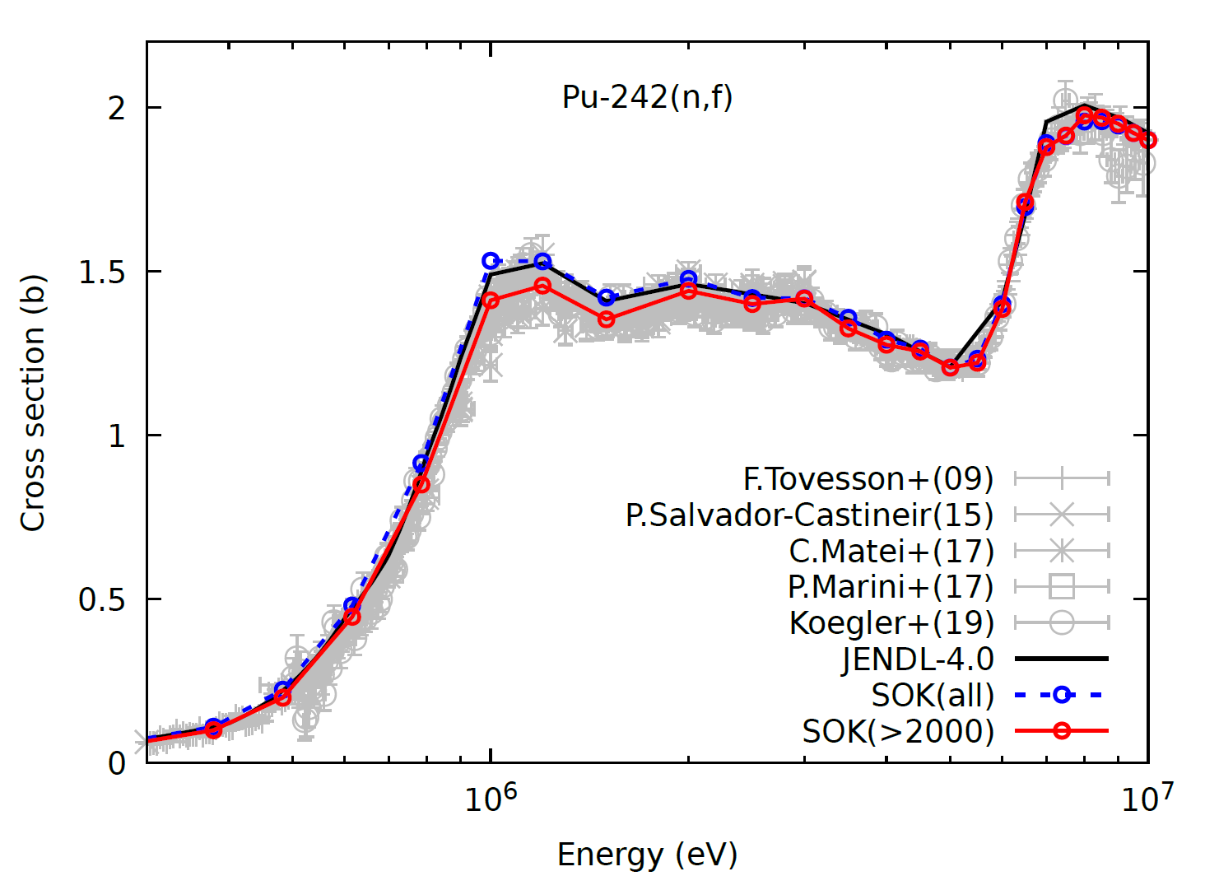
Fig. 1 Neutron induced fission cross section of ²⁴²Pu. Blue and red curves with circles shows the evaluated results with all experimental data and ones limited after 2000, respectively. Black line indicates JENDL-4.0. Recent experimental data are shown by gray symbols.

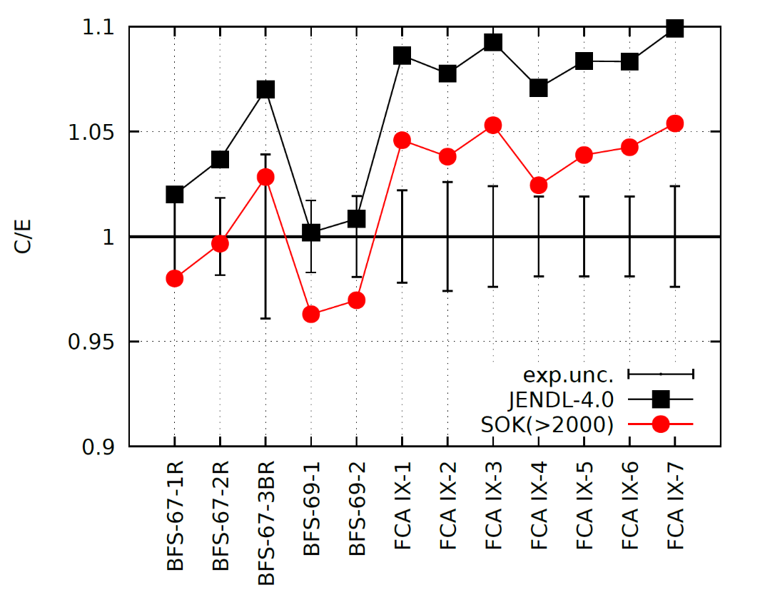
Fig. 2 Fission reaction rate ratio of ²⁴²Pu to ²³⁹Pu for fast reactors. C/E values for JENDL-4.0 is shown by black squares and estimation for new evaluation with sensitivities is indicated by red circles.

